**Design and Implementation of a Data Warehouse for a Retail Store with Store-level Data**

Texas A&M University

George, Alpha

Rafi, Parvez

Shetty, Sharvil

Table of Contents

A. Introduction 4

1. Potential impacts 4

2. Details about the Data 5

2.1. Understanding of the data 5

2.2. Metadata description for all OLTP files 6

2.3. Entity-Relationship diagram 10

3. Domain Understanding 11

B. Business questions and their substantiations and explanations 13

1. Business Questions 13

*1.1.* What is the trend of beer sales during Christmas holiday season? 13

*1.2.* Which stores have more popularity among kids and elderly groups? 14

*1.3.* Which stores attract people who earn below poverty line? 16

*1.4.* What is the effect of introducing coupons on total number of customer visits? 17

*1.5.* What is the trend of a product demand in different price-tiers? 18

C. Independent Data Marts design using Kimball’s approach 20

1. Proposed schema 20

2. Kimball’s Matrix for Data Marts 20

3. Star Schema representation 21

4. Mapping tables 23

5. Business question justification corresponding to proposed schema 26

D. Data Integration 31

1. Data Quality Issues with Dominick’s Finer Food Data 31

2. ETL Development Plan 33

3. ETL Implementation 34

3.1. Determine the target data 34

3.2. Determine Source data 35

3.3. Mapping tables for staging and data mart loads. 36

3.4. Comprehensive Data Extraction Rules 45

3.5. Screenshots of Data Staging area 47

3.6. Data Transformation and Cleansing Rules 50

3.7. Plan for Aggregation 52

4. Data Loading 54

4.1. Mapping definition describing the source to end table for all dimension and fact tables 58

4.2. SQL statements used for the ETL operations 61

4.3. Staging and Data Mart table screen shots 62

E. BI reporting 70

1. BI Reports Design and Implementation 70

1.1. Reporting plan 70

1.1.1. Determining all target reports that satisfy business questions 70

1.2. Mappings from the tables in the data marts to the attributes in the report 72

1.3. Cube from SSAS and Report from SSRS on top of SSAS for Question 1 77

1.4. SSRS Reporting from Independent Data Mart using for Question 2 86

1.5. Report generated using Report builder 3.0 for Question 3 92

1.6. Report generated using Report builder 3.0 for Question 4 97

1.7. Cubes using SSAS from an independent data mart for Question 5 101

References 106

# **Introduction**

Dominick’s was a retail store chain founded in 1918 and headquartered in Illinois. The data being analyzed in this report is from Dominick’s Fine Food's (DFF) database through Chicago Booth collected after both formed a partnership for store-level research into shelf management and pricing. The data encompasses 25 product categories sold at DFF’s 100 retail chain stores located in the Chicago metropolitan area over the years from 1989 to 1997. The research is of the data and developing a data warehouse on top it, would help DFF systematically analyze the factors that influence product sales. This project report aims at formulating business questions that aim to analyze these factors and help in solving key business problems such as follows.

# **Potential impacts**

1. **Proper shelf-management for sales growth.** The sales increase tactics can broadly be classified under two categories.
2. *Out-of-store tactics*- they include tactics to attract more consumers or retain existing ones against external competitors.
3. *In-store tactics*- it includes tactics to increase sales once consumers are inside the stores.

*Shelf-management* is an in-store tactic, which focuses on how retailers can boost sales through store-level shelf-management. The analysis of data through UPC scanners makes it *possible to understand* heterogeneity of local area demand. One of the challenges that DFF faces is how it should allocate shelf space to the multitude of products they sell across stores.

1. **Effect of consumer demographics on product sales.** Another key problem DFF needs to address is how distribution of consumer’s age, economic health, household sizes affect the sales across product categories. Answers to these problems would help DFF in targeted marketing.
2. **Impact of location of stores on sales.** DFF has more than 100 retail stores in Chicago. The store-level research on product sales also aims at answering how positioning of stores translates into revenue for DFF and what makes shoppers choose one store over another.
3. **Making pricing decisions based on seasons.** Retail stores usually see spikes in sales during vacation seasons such as Thanksgiving and Christmas. It is important for DFF to determine optimal prices of the products that would increase profit margin during these seasons.
4. **Effect of price promotions.** DFF has been rolling out coupons across product categories for promotions. They need to analyze whether price promotions through strategies like Coupons help any sales growth.

# **Details about the Data**

## Understanding of the data

As a part of the project, we are planning to do analysis on data collected from James M. Klits Center, University of Chicago Booth School of Business. Total size of this data adds up to 4.76 GB needs lot of changes to convert this dirty data to perform meaningful analysis. The data comprises of 9 years of store level data of more than 3500 UPCs, which were sold through around 100 stores across United States. Most of the Stores are located in Chicago area. We need to analyze the data from 1989-1994 for same number of stores. The complete product line is classified in to 29 different categories.

In total, there are four data files and they can be classified in to two categories namely General files and Category files. These four data files are available in .csv format for the analysis of the sales of Dominick’s FF.

1. **Customer Count Files**

* This file contains the information about in-store traffic of all the stores, which were compiled, on a weekly basis from scanners located at each store in DFF.
* This table contains the information about the sale information of each product categories of Beer, Meat, grocery and Diary etc. store wise on weekly basis.
* This file also contains the separate information of each above product purchased using Coupons at each store in DFF chain on weekly basis.

1. **Store-Specific Demographics**

* This file contains the store wise information of all the customers purchased the products from DFF on weekly and demography basis.
* Information present in this file is obtained by mapping the customer information with the Census information collected by US government for Chicago Metropolitan area.
* Various demography information available in this file include age groups, household income, and number of dependent members, employment status, and retired status of every customer.
* Demographic information is the most important in later stages of the project for Data Warehousing and building different store wise strategies targeting different demography of people. This file has very importance in framing the questions in this phase of the project.

1. **UPC Files**

* As the name indicates UPC means Unique Product Code. Each Product is mapped to a UPC and other information related to that product.
* Complete mapping of UPC code to product is available in the *List of all UPCs in the category* table. This information can be used for product specific strategies for DFF.

1. **Movement Files**

* This file contains category wise weekly movement of each product in DFF.
* Information in this file give clear idea about profit margin on each product. This in turn will give idea about strategies need to be adopted by DFF to reduce losses and increase profit. This very important in Business point of view.
* If the Sale quantity is predictable after analyzing weekly sale data, it will give strategic advantage to the inventory department of DFF in preparing for peak and off seasons.

In addition to the above data sources, we have “Weeks Decode Table” which gives the week to date mappings useful for analysis. This is very useful in formulating different business strategies.

## Metadata description for all OLTP files

1. Please find below the description for each attribute in **ccount** file.

|  |  |  |  |
| --- | --- | --- | --- |
| **Variable** | **Description** | **Variable** | **Description** |
| DATE | Date of the Observation | FTGITAL | Food-to-Go Italian Sales in Dollars |
| Week | Week Number | GM | General Merchandise Sales in Dollars |
| Store | Store Code | GMCOUP | General Coupons Redeemed |
| BAKCOUP | Bakery Coupons Redeemed | GROCCOUP | Grocery Coupons Redeemed |
| BAKERY | Bakery Sales in Dollars | GROCERY | Grocery Sales in Dollars |
| BEER | Beer Sales in Dollars | HABA | Health and Beauty Aids Sales in Dollars |
| BOTTLE | Bottle Sales in Dollars | HABACOUP | Health and Beauty Aids Coupons Redeemed |
| BULK | Bulk Sales in Dollars | JEWELRY | Jewelry Sales in Dollars |
| BULKCOUP | Bulk Coupons Redeemed | LIQCOUP | Liquor Coupons Redeemed |
| CAMERA | Camera Sales in Dollars | MANCOUP | Manufacturer Coupons Redeemed |
| CHEESE | Cheese Sales in Dollars | MEAT | Meat Sales in Dollars |
| CONVFOOD | Conventional Foods Sales in Dollars | MEATCOUP | Meat Coupons Redeemed |
| COSMCOUP | Cosmetics Coupons Redeemed | MEATFROZ | Meat-Frozen Sales in Dollars |
| COSMETIC | Cosmetics Sales in Dollars | MISCSCP | Misc. Coupons Redeemed |
| CUSTCOUN | Customer Count | MVPCLUB | MVP |
| DAIRCOUP | Dairy Coupons Redeemed | PHARCOUP | Pharmacy Coupons Redeemed |
| DAIRY | Dairy Sales in Dollars | PHARMACY | Pharmacy Sales in Dollars |
| DELI | Deli Sales in Dollars | PHOTCOUP | Photo Coupons Redeemed |
| DELICOUP | Deli Coupons Redeemed | PHOTOFIN | Photo |
| DELIEXPR | Deli Express Sales in Dollars | PRODCOUP | Produce Coupons Redeemed |
| DELISELF | Deli Self Service Sales in Dollars | PRODUCE | Produce Sales in Dollars |
| FISH | Fish Sales in Dollars | PROMCOUP | Promotion Coupons Redeemed |
| FISHCOUP | Fish Coupons Redeemed | PROMO | Promotion Sales in Dollars |
| FLORAL | Floral Sales in Dollars | SALADBAR | Salad Bar Sales in Dollars |
| FLORCOUP | Floral Coupons Redeemed | SALCOUP | Salad Coupons Redeemed |
| FROZCOUP | Frozen Items Coupons Redeemed | SPIRITS | Spirits Sales in Dollars |
| FROZEN | Frozen Items Sales | SSDELICP | Self Service Deli Sales in Dollars |
| FTGCCOUP | Food-to-Go Coupons Redeemed | VIDCOUP | Video Coupons Redeemed |
| FTGCHIN | Food-to-Go Chinese Sales in Dollars | VIDEO | Video Sales in Dollars |
| FTGICOUP | Food-to-Go Coupons Redeemed | VIDEOREN | Video Rentals (Dollar Amounts) |

1. Please find below the description for each attribute in **Demography** file.

|  |  |  |  |
| --- | --- | --- | --- |
| **Variable** | **Description** | **Variable** | **Description** |
| age9 | % Population under age 9 | retired | % of Retired |
| age60 | % Population over age 60 | unemp | % of Unemployed |
| ethnic | % Blacks & Hispanics | wrkch5 | % of working women with children under 5 |
| educ | % College Graduates | wrkch17 | % of working women with children 6 - 17 |
| nocar | % With No Vehicles | nwrkch5 | % of non-working women with children under 5 |
| income | Log of Median Income | nwrkch17 | % of non-working women with children 6 - 17 |
| incsigma | Std dev of Income Distribution (Approximated) | wrkch | % of working women with children |
| hsizeavg | Average Household Size | nwrkch | % of non-working women with children |
| hsize1 | % of households with 1 person | wrkwch | % of working women with children under 5 |
| hsize2 | % of households with 2 persons | wrkwnch | % of working women with no children |
| hsize34 | % of households with 3 or 4 persons | telephn | % of households with telephones |
| hsize567 | % of households with 5 or more persons | mortgage | % of households with mortgages |
| hh3plus | % of households with 3 or more persons | nwhite | % of population that is non-white |
| hh4plus | % of households with 4 or more persons | poverty | % of population with income under $15,000 |
| hhsingle | % of households with 1 person | shopcons | % of Constrained Shoppers |
| hhlarge | % of households with 5 or more persons | shophurr | % of Hurried Shoppers |
| workwom | % Working Women with full-time jobs | shopavid | % of Avid Shoppers |
| sinhouse | % Detached Houses | shopstr | % of Shopping Stranges |
| density | Trading Area in Sq Miles per Capita | shopunft | % of Unfettered Shoppers |
| hval150 | % of Households with Value over $150,000 | shopbird | % of Shopper Birds |
| hval200 | % of Households with Value over $200,000 | shopindx | Ability to Shop (Car and Single Family House) |
| hvalmean | Mean Household Value (Approximated) | shpindx | Ability to Shop (Car and Single Family House) |
| single | % of Singles |  |  |

1. Please find below the description for each attribute in **UPC** file

|  |  |  |  |
| --- | --- | --- | --- |
| **Variable** | **Description** | **Variable** | **Description** |
| upc | UPC Number | descrip | Product Name |
| com_code | % Population over age 60 | size | Product Size |
| nitem | Dominick's item code | case | Number of items in a case |

1. Please find the description for each attribute in **Movement** file

|  |  |  |  |
| --- | --- | --- | --- |
| **Variable** | **Description** | **Variable** | **Description** |
| upc | UPC Number | qty | Number of item bundled together |
| store | Store Number | profit | Gross margin |
| week | Week Number | sale | Sale code (B, C, S) |
| move | Number of unit sold | ok | 1 for valid data, 0 for trash |
| price | Retail Price |  |  |

## Entity-Relationship diagram



# **Domain Understanding**

We had a pool of research papers to understand how significant and relevant data can be derived from past sales data. Research papers also gave insight about methods by which we can build business strategies on top of the derived data. It was beyond the scope of the project to read and understand all the papers from the pool of research papers. From the complete list, we read three and understood the strategies adopted during the design and implementation of Data Warehousing. Please find our understandings about each paper detailed below.

In their research Nevo, et al [1] summarize the effect of Coupons in the increase or decrease in sales of any retail chain. This paper discusses the scenarios in which the coupons are introduced by a Manufacturers and the effect of it in detail. Paper also discusses that giving coupons is better than spending substantial amount in advertisements. This paper also explains how the price of commodities whose quality is not comparable to its competitors will decrease in long term .This is very important in formulating our strategies in later stages of the project for improving sales based on the meaningful data derived from data warehousing design methodologies.

Nevo, et al also discusses different reasons behind a manufacturer introducing discount/coupon on a particular product. Firstly, it can be for introducing a new product. This will give a larger pool of customers a taste/experience of the new product. Secondly coupons are introduced to boost up sales of a particular product which is lagging behind its customers or if it is being perished in inventory. This is explained under the heading relationships between Coupons and Shelf price. In addition, the paper discusses how the perception of customer about a product can change if the coupons are made available continuously. Effects and correlation of price and coupons in different situations are derived and explained mathematically in the complete paper. This summarizes the complete project.

Sivakumar, et al [2] talk about implications of quality-tier competition by developing a conceptual framework to investigate how optimal pricing decisions can be done the level of brand quality to which it belongs. This paper explained how comparative study could be done on 2 different products about its pricing. It also discusses the implication of the framework introduced and steps involved in the implementation of the framework. This will be very helpful in adopting strategies for pricing the items in DFF considering the competition faced by the product after getting results from the data warehouse we are planning to design in the upcoming stages of the project.

Sivakumar, et al also give insight into Customer decision model explaining what will be the possible decisions of a customer comparing the price and brand category of 2 products competing each other. This idea is very useful in determining what the possible price of each product is, considering the utilities derived from it. The framework described in this paper proposes the empirical distribution of possible prices for a product. It also describes the profit available from each price in the distribution and managerial implication of the same. In total, the paper draws a complete relation between the academic researches in marketing practices of pricing a product.

Lira, et al [3] suggest whether the prices in retail sector decrease when there is a positive demand in the product. This explained in the backdrop of countercyclical relationship of in Chile between cost and increased demand of set of retail products. This paper discusses about various theories analyzing the effect and cause of prices in each theory scenario. Author discusses theories effecting the prices at Producer/Supplier level and Retail level. For example, pro cyclical Price elasticity proposed by Warner Barsky states that Producer price could drop for products experiencing increase in the elasticity of demand. This can happen due to transferring of elasticity of demands to suppliers in periods of generalized shocks in demand. If similar situation arises for a product in DFF for a particular week DFF management transfer the benefit to customers by applying the same principle.

So similarly applying other theories in the paper, equations can be written for each product in DFF on weekly basis considering the changes in sales of the particular product in previous week. Even though applying equations for pricing on each product is not in the purview of the project even in later stages, we can apply these in one or two products if the time permits. The paper also says that above theories stand null and void when the demand of a product is artificially increased by applying coupons. All theories are explained with the variation in price of products in a retail chain at Chile. Results of the study proves that price of set of retail products fall when the demand increases, which is likely to be similar in case of DFF as the scenarios are same in both the cases.

# **Business questions and their substantiations and explanations**

# **Business Questions**

# **What is the trend of beer sales during Christmas holiday season?**

**Data Table:**

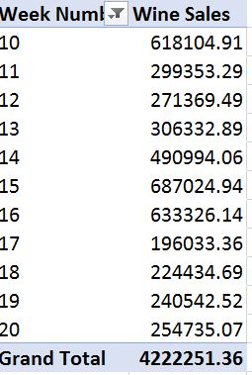

*Table.2. Weekly sales trends for beer around Christmas Week*

**Graphical Analysis:**

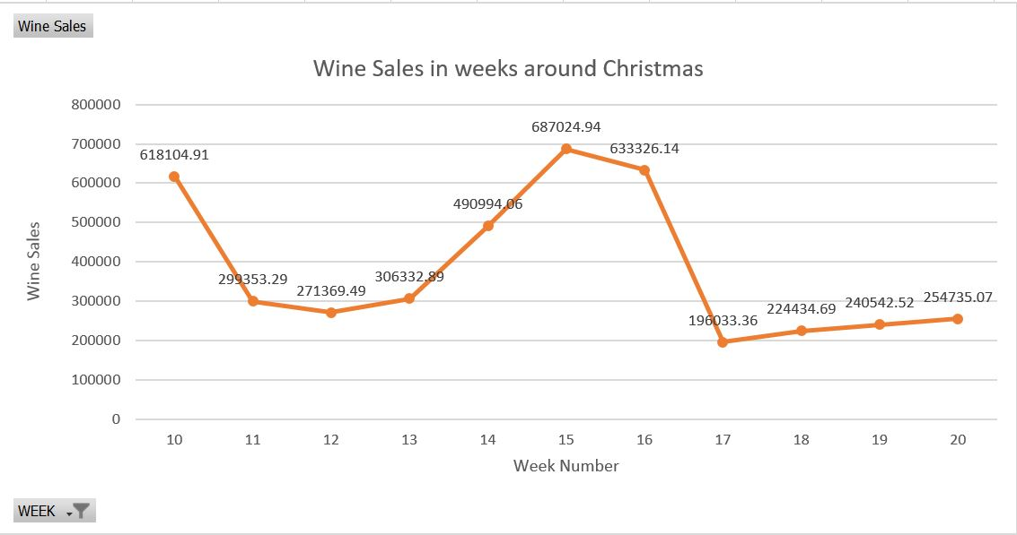

*Fig. 2. Weekly sales trends for beer around Christmas Week*

**Explanation:** Some products may see significant boost in sales during festive/vacation seasons. One such product is beer which saw sudden growth from week 13 through week 17 (Christmas through New Year). Such an analysis will help DFF identify all the products which usually see seasonal growth in sales. The supplies of these products would need to be managed effectively during these seasons. Proper shelf-management has always been one of important concerns for retails businesses. This type of analysis would help in better management of the products that would feature on store shelves.

# **Which stores have more popularity among kids and elderly groups?**

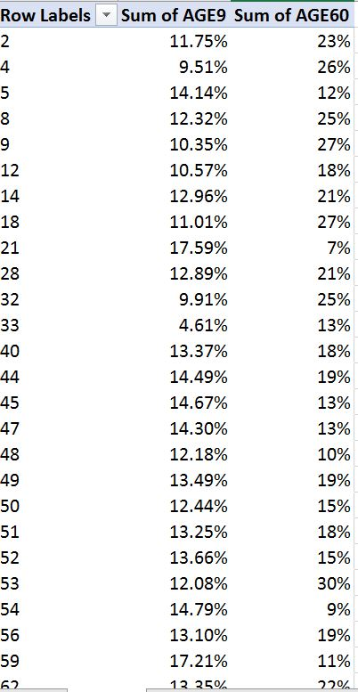

*Table. 3. Store-wise percentage visit of kids(age<9) and elderly people(age>60)*

**Graphical Analysis:**

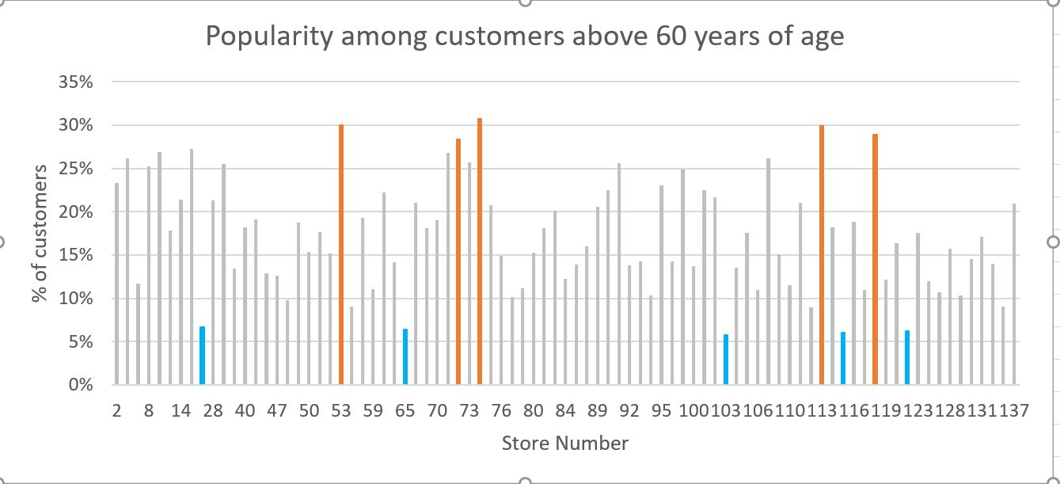

*Fig. 3.A. Store-wise percentage visit of elderly people(age>60)*

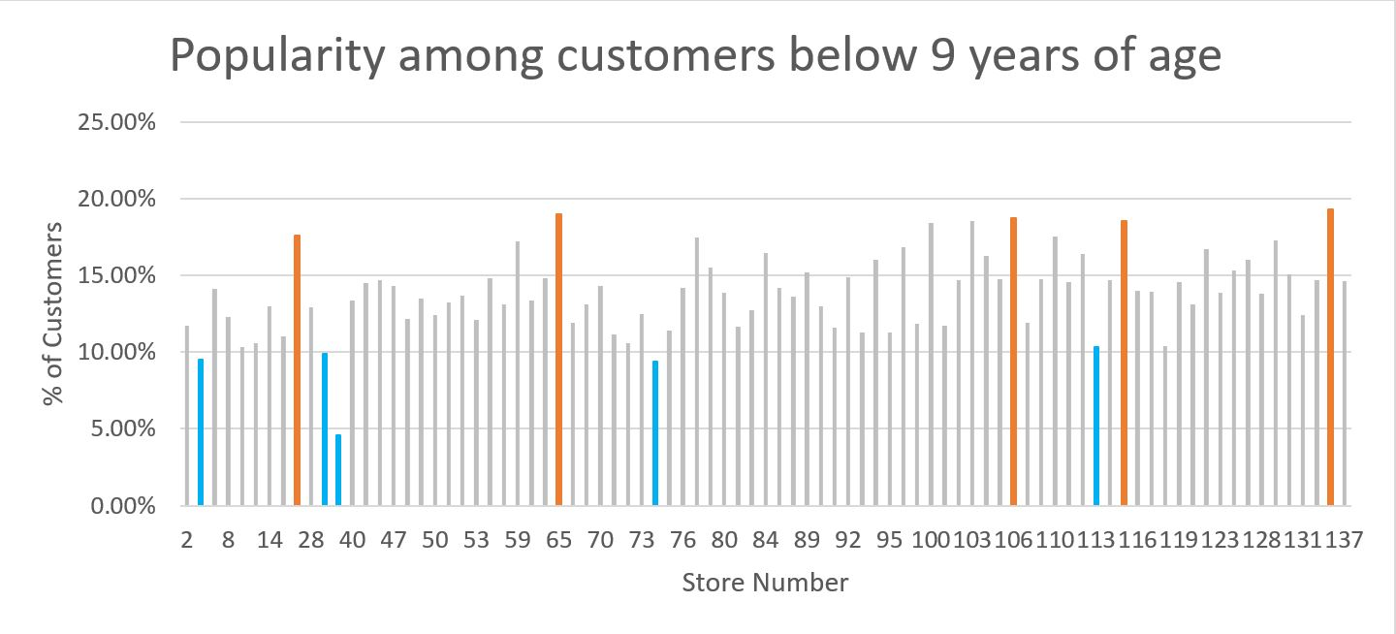

*Fig. 3.B. Store-wise percentage visit of kids(age<9)*

**Explanation:** The graphs above highlight the DFF stores which are most or least popular among kids and elderly group people. Retails companies require such analysis for targeted marketing and sales. For instance, the stores which are popular among kids may be supplied with more of young age merchandize. Similarly, the stores that are popular among elderly section may be supplied with merchandize that sell more to elderly people.

# **Which stores attract people who earn below poverty line?**

**Data Table:**

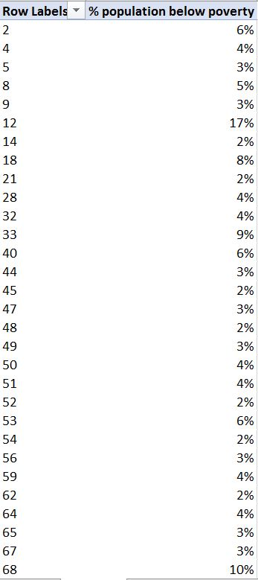

*Table. 4. Store-wise percentage of Poor People (annual salary<$15,000)*

**Graphical Analysis:**

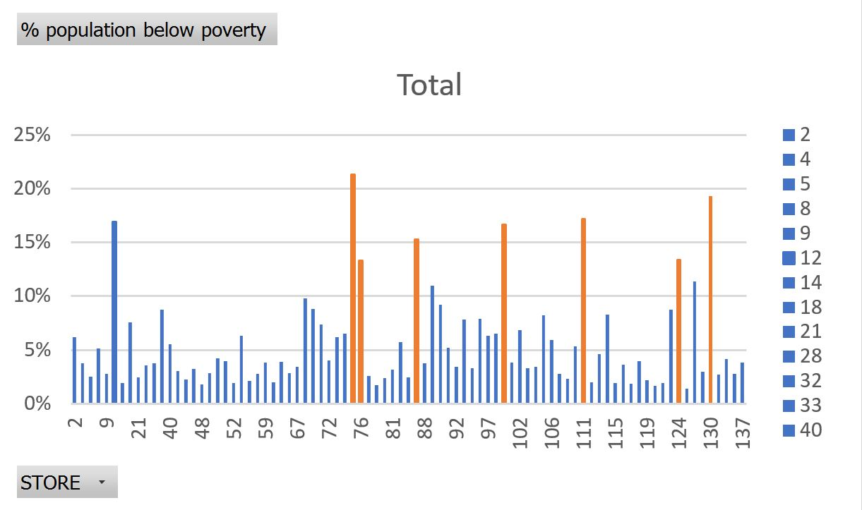

*Fig. 4. Store-wise percentage of Poor People (annual salary<$15,000)*

**Explanation:** The plot above shows percentage of people below poverty line (income less than $15,000) visiting stores of DFF. We realized that some of the stores were more popular among low income group people. Such an analysis is important for DFF for store-wide distribution of the stock which is usually consumed more by low-income group. For example, low income group usually consumes non-luxury goods more. If we can identify these stores, DFF would be able to make to distribute such goods more effectively.

# **What is the effect of introducing coupons on total number of customer visits?**

**Data Table:**

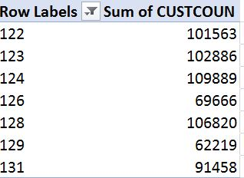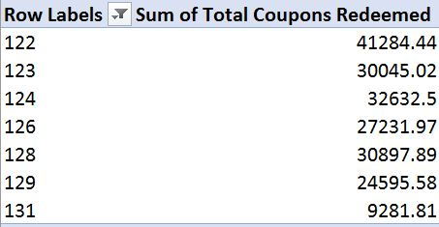

*Table. 5.A. Count of customers per week Table. 5.B. Count of Coupons used per week*

**Graphical Analysis:**

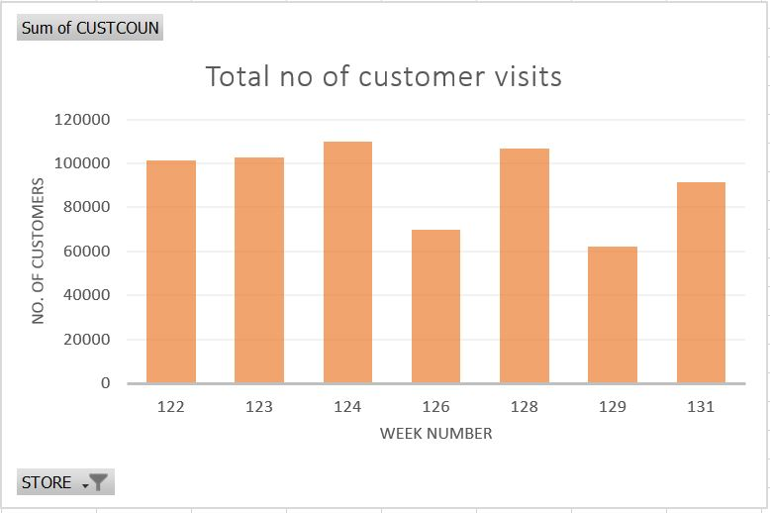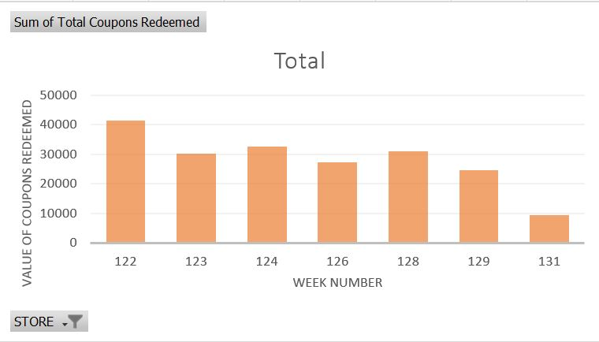

*Fig. 5.A. Count of customers per week Fig. 5.B. Count of Coupons used per week*

**Explanation:** With data and graph above help analyze the impact of coupons on count of customers who visited DFF stores over a certain period of observation. We assume that number of coupons that were redeemed is in proportion to the coupons launched. The analysis is needed to understand how customer footfall varied as DFF launched promotional strategies like announcing coupons. We can repeat similar exercise for other promotional strategies and see how each impacts the customer count. This will help identify the effectiveness of such promotional strategies. The analysis will also help to see one promotional strategy fares against other marketing forces in their effect on customer visits.

# **What is the trend of a product demand in different price-tiers?**

**Data Table:**

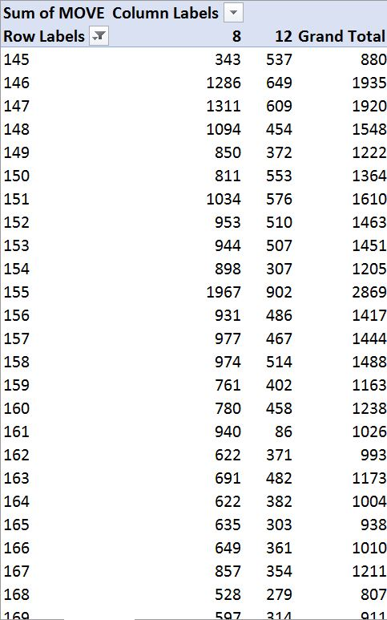

*Table. 6. Weekly sales of Cheese in store 8(medium-price tier) store 12(high-price tier)*

**Graphical Analysis:**

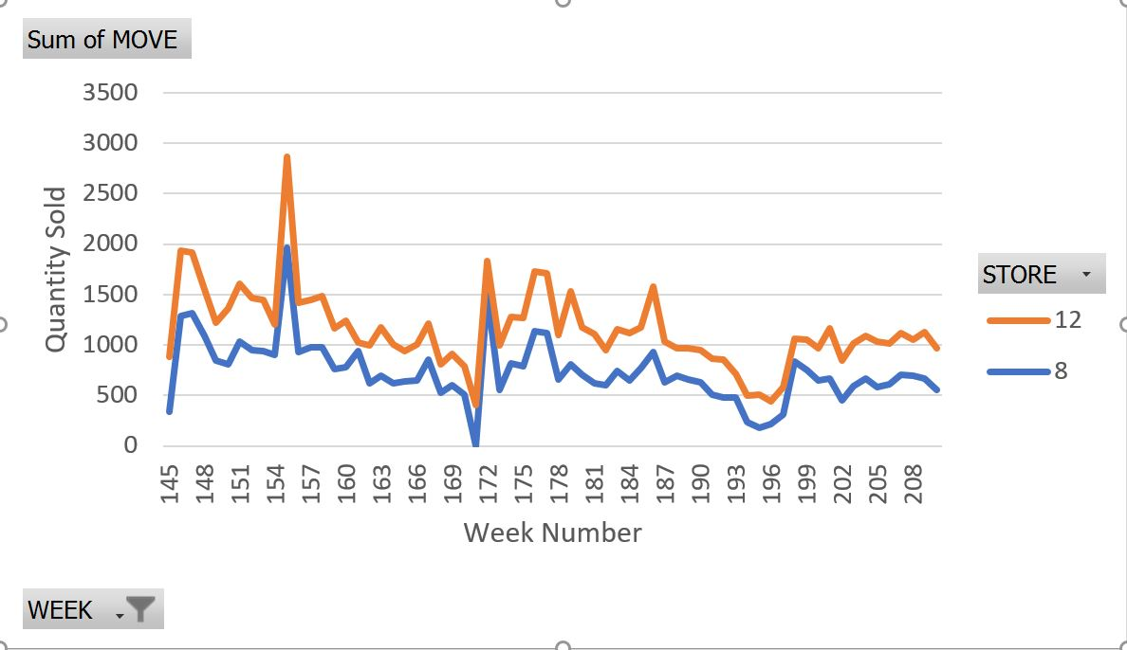

*Fig. 6. Weekly sales of Cheese in store 8(medium-price tier) store 12(high-price tier)*

**Explanation:** The plot above compares quantities of Cheese sold in two stores in difference price-tier zones. The store Dominick 12 is in high-price trier zone, while the store Dominick 8 is in low price tier zone. One possible explanation for the trend as above could be high-price zones being in rich neighborhoods where people can afford to buy more. Such an analysis is important in distributing merchandize based on price-tier zones. Out of 16 zones in which different stores are located, they can be divided into 4 price tiers viz. *CubFighter, Low, Medium, High*. In this analysis, we cover only medium-price and high-price tiers. Similar analysis may be expanded to other price tiers which would help in comparative study of the demand trends across these 4 price tiers.

# **Independent Data Marts design using Kimball’s approach**

# **Proposed schema**

The schema being proposed to answer the above business questions is a combination of the five dimensions viz. Store, Product, Time, Demographic, Coupon and two fact tables- SALES_FACT which will hold the data from the MOVEMENT source file and STORE_VISITS_FACT which will hold the data from the CCOUNT source file.

The dimension STORE_DIM dimension contains details about all the DFF stores. This dimension is populated with data from the Dominic’s research project manual, which contains the details about each store under the DFF retail chain. It has an inherent hierarchy in Zone, City and Store number. The PRODUCT_DIM dimension contains the data related to all the products sold at DFF. The UPC files for each product act as the source for this data. It is a collection of data from each of the categories of products. The product category column is populated from the name of the csv file from which the data is being loaded. The TIME_DIM dimension contains the data related to the occurrence of an event. The attribute TIME_ID is an auto incremented surrogate key, acting as the primary key for the table. As stated in the manual, the data contains observations from week 0 to 400, based on this fact, the field WEEK is auto populated. The WEEK acts as the base to calculate MONTH and YEAR as described in the transformation for the time dimension. The COUPON_DIM dimension stores all the types of coupons there are available at the stores. This value is derived from the header column of the CCOUNT.csv file. It is a manual task to separate out the names of the fields, which represent the coupon usage in the dataset. The DEMOGRAPHIC_DIM dimension is derived from the DEMO.csv table. It stores all the demographics related to each store. It contains clearly defined statistics for various demographic factors, which are directly mapped from the source table.

The SALES_FACT table stores the values derived from the movement datasets. Product, Store and Time. The STORE_VISITS_FACT is designed to address business question 2, 3 and 4. This fact table enables us to answer the queries related to introduction of coupons and customer visits. The CUSTOMER_COUNT stores the number of customers who visited the store.

# **Kimball’s Matrix for Data Marts**

|  |  |  |  |  |  |
| --- | --- | --- | --- | --- | --- |
| **Data mart** |  | **Dimension** |  |  |  |
|  | STORE_DIM | TIME_DIM | PRODUCT_DIM | DEMOGRAPHIC_DIM | COUPON_DIM |
| Sales | x | x | x |  |  |
| Store visits | x | x |  | x | x |

# **Star Schema representation**



*Fig: Star schema for Sales data mart*



*Fig: Star schema for Store visits data mart*

# **Mapping tables**

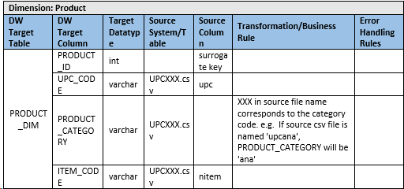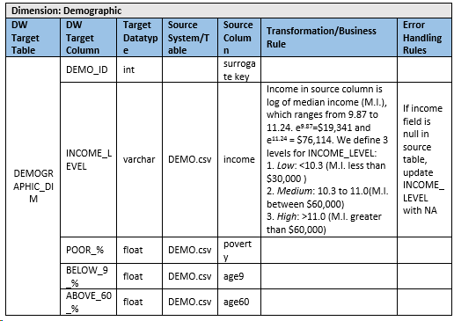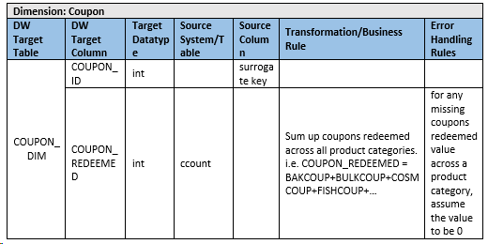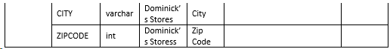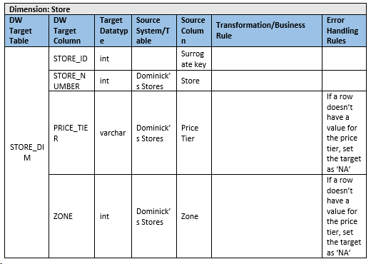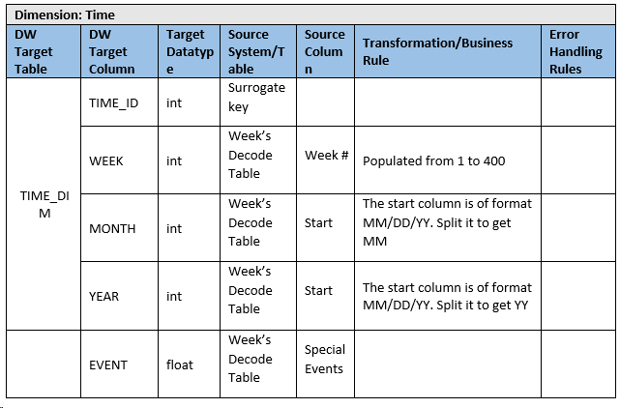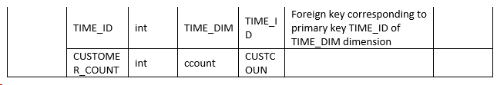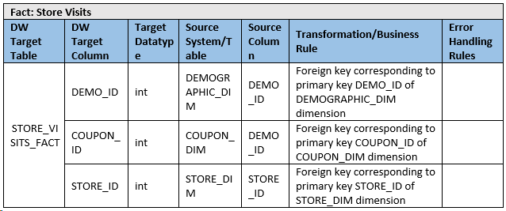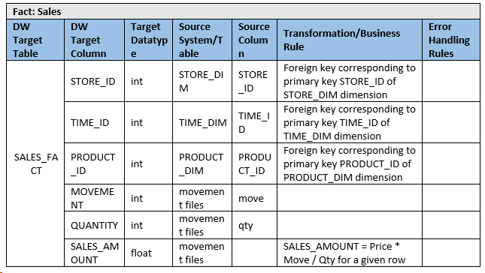

# Business question justification corresponding to proposed schema

Please find the explanation of how we can answer all the five business question using the above two schemas below.

#### **BQ** **1: What is the trend of beer sales during Christmas holiday season?**

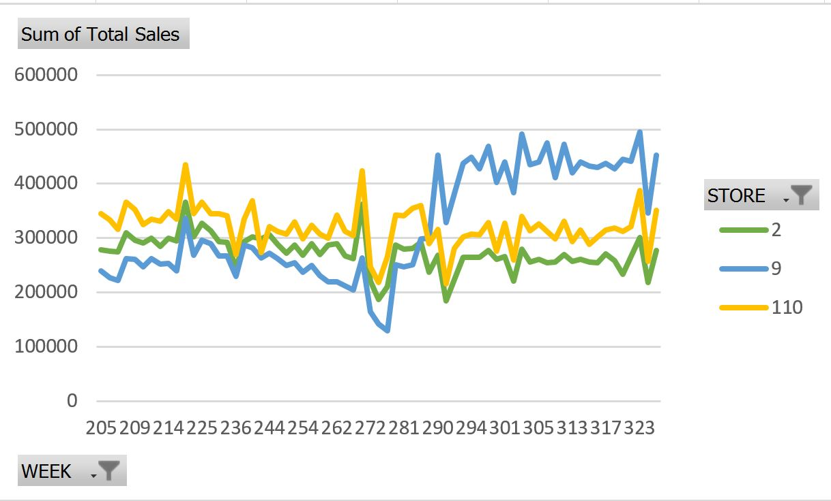

This business question is addressed by analyzing the Beer sales during the Christmas weeks as shown in the above graph. Same analysis can also be done with the Sales data mart shown above. Here the product under consideration is Beer, information related to that can be obtained from PRODUCT_DIM dimension table and Week related information could be taken from WEEK attribute loaded in TIME_DIM dimension table. Beer Sales related information corresponding to each week during Christmas week can be mapped from SALES_FACT fact table in Sales data mart.

#### **BQ 2:** **Which stores have more popularity among kids and elderly groups?**

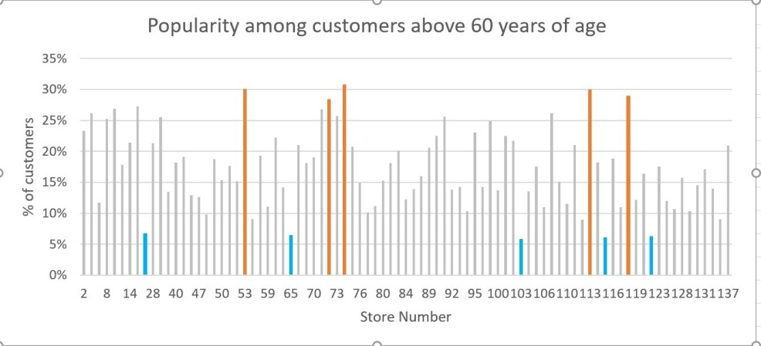

Store visits data mart can be used for analyzing this business question. Number of people below age 9 (BELOW_9_ %) and above 60(ABOVE_60_ %) are attributes in DEMOGRAPHIC_DIM dimension table and Store Number plotted the above graph can be plotted from attribute STORE_NUMBER from STORE_DIM dimension table. Comparing the two values, the number of store visits, CUSTOMER_COUNT is obtained from STORE_VISITS_FACT fact table. Above graph will help us analyze just the popularity among people above age 60. For answering this business question completely, popularity of stores among kids and elderly group will be analyzed separately in similar way.

#### **BQ 3:** **Which stores attract people who earn below poverty line?**



This business question can be analyzed similar to Business Question 2. Same Store visits data mart can be used for analysis. IS_POOR attribute is available in DEMOGRAPHIC_DIM table and store number STORE_NUMBER is obtained from STORE_DIM table. For each corresponding values of STORE_NUM and IS_POOR we can get the CUSTOMER_COUNT from STORE_VISITS_FACT table given in the schema. This data can be used to analyze store attraction among people below poverty line.

#### **BQ 4:** **What is the effect of introducing coupons on total number of customer visits?**



This is comparatively complex business question to analyze even though it is easy to understand. For analyzing the question we need to plot and compare the Total number of customer visits and Total number of coupons redeemed on a weekly basis. Comparing the trend in both the graph’s we can reach at a conclusion of effect of coupons on customer visits. So here the Store visits data mart can be used again for analysis. CUSTOMER_COUNT attribute from STORE_VISITS_FACT fact table can be plotted against the WEEK attribute loaded in TIME_DIM dimension table form the schema. Similarly, for plotting the second graph we need calculate the value derived from the summation of coupon sales from different product category, which is given in CCount table. This summed up value is stored in COUPON_DIM dimension table as COUPON_REDEEMED attribute. COUPON_REDEEMED attribute from COUPON_DIM dimension table can be used for plotting the second graph. So now with the two graph’s plotted from the data loaded to dimension tables and fact tables we can easily find the effect of introducing coupons in total number of customer visits.

#### **BQ 5:** **What is the trend of a product demand in different price-tiers?**



This business question can be answered by plotting the weekly sales data of each Shop tiers (A, B, C). For this Business question, we can use Sales data mart. In Sales data mart the PRICE_TIER information is loaded in STORE_DIM dimension table and WEEK related data is stored in TIME_DIM dimension table. All the sales related information for all the shop price tiers can be collected from the SALES_AMOUNT attribute in SALES_FACT fact table. This information is plotted for each shop tiers and the distribution of sales in each shop tier can easily be analyzed from the plot.

# **Data Integration**

# Data Quality Issues with Dominick’s Finer Food Data

The dataset provided by DFF has been highly useful to answer our business questions but the data quality had to be improved in order to make the data useful. We discovered following issues with the data while developing our data warehouse.

|  |  |  |  |
| --- | --- | --- | --- |
| Group | Quality | Issues Considered | Data Quality Problem encountered with DFF |
| **Relation to the other data** | Referential Integrity | Do tables in DDFF datasets have table/file references intact? | Referential integrity in between tables/files was mostly missing, but for some of the tables we linked them using common columns. To link ccount and movement tables we used store numbers. To link UPCXXX files with sales data in ccount, we had to extract product categories(XXX) from files names. Many product categories e.g. Beer which we extracted from UPC files had corresponding movement/ccount data missing. |
| Cardinality | Is the structure of relationships among entities and attributes maintained consistently? | The relationships between entities and attributes were highly inconsistent e.g. UPC numbers of products in Movement data and the UPC files were inconsistent for some of the cases. |
| **Structure of fields** | Format | Do values follow consistent formatting standards? | The UPCXXX.csv files names were consistent and helped us find list of product categories. Date field in ccount table even though was not in an easily extractable format, but the format throughout the file was consistent i.e. XXXXXX. |
| Standard | Are data elements consistently defined and understood? | Store number followed standard integer format which helped linked tables like ccount and demographic. The format of date field in ccount and that in start, end dates in week table were dissimilar. The date in ccount was formatted as YYMMDD, while in week table is given as MM/DD/YY. |
| Consistent | Do values represent same meaning across systems and files? | Most of the attributes e.g. Store Number, Week Number had consistent meaning across the tables. The attributes were clearly explained in the data manual of DFF. |
| **Content within data values** | Complete | Is all necessary data present? | Many data values were missing that we needed to answer our business questions with. E.g. Many date values were missing from ccount. Also, UPC data contained more product categories than we had sales figures for. |
| Accurate | Does the data accurately represent reality? | Most of the data accurately represented data DFF’s business. However, demographic table had demographics in percentage terms instead of absolute number of customers. The count of customers as an additional data column would have provided better understanding. |
| Valid | Do data values fall within acceptable ranges defined by the business? | Dominic stores had Store numbers starting from 2, while many ccount records had store values as 0 and 1. We had excluded these records for business question where we analyzed store-wise sales trends. |
| Fit for purpose | Is the information valuable to the business? Does the data convey information that can intelligently be consumed by the business? | DFF contains and exhaustive amount of data collected over a long period of more than 5 years. Such data can be used to provide lot of insights. The data is highly valuable to the business as it can help in understanding marketing trends, demand-supply relations and thus would help in formulating more effective sales strategies. |

# ETL Development Plan

Based upon the previous reports developed, ETL Development Plan is designed to outline the roadmap for the data load process into the data warehouse.

The proposed plan is presented as:

* Determine the target data
* Determine the source data
* Mapping tables for staging and data mart loads
* Comprehensive data extraction rules
* Data staging area and screen shots
* Data transformation and cleansing rules
* Plan for aggregate tables
* Procedures for data extraction and loading
  + ETL for dimension tables
  + ETL for fact tables
* The implementation is shown as:
* Mapping definition describing the source to end table for all dimension and fact tables
* SQL statements used for the ETL operations
* Before and after table screen shots

# ETL Implementation

## Determine the target data

Our proposed dimensional model contains 5 dimension tables and 2 fact tables. Please find the definitions for each of them at Data Warehouse area below.

**Dimensional Tables**

|  |  |  |
| --- | --- | --- |
| **Dimension: Product** | | |
| **DW Target Table** | **DW Target Column** | **Target Datatype** |
| 601-Group11-DW-Area.PRODUCT_DIM | PRODUCT_ID | int |
| UPC_CODE | varchar |
| PRODUCT_CATEGORY | varchar |
| ITEM_CODE | varchar |

|  |  |  |
| --- | --- | --- |
| **Dimension: Demographic** | | |
| **DW Target Table** | **DW Target Column** | **Target Datatype** |
| 601-Group11-DW-Area.DEMOGRAPHIC_DIM | DEMO_ID | int |
| INCOME_LEVEL | varchar |
| POOR_% | float |
| BELOW_9_% | float |
| ABOVE_60_% | float |

|  |  |  |
| --- | --- | --- |
| **Dimension: Coupon** | | |
| **DW Target Table** | **DW Target Column** | **Target Datatype** |
| 601-Group11-DW-Area.COUPON_DIM | COUPON_ID | int |
| COUPON_REDEEMED | int |

|  |  |  |
| --- | --- | --- |
| **Dimension: Store** | | |
| **DW Target Table** | **DW Target Column** | **Target Datatype** |
| 601-Group11-DW-Area.STORE_DIM | STORE_ID | int |
| STORE_NUMBER | int |
| PRICE_TIER | varchar |
| ZONE | int |

|  |  |  |
| --- | --- | --- |
| **Dimension: Time** | | |
| **DW Target Table** | **DW Target Column** | **Target Datatype** |
| 601-Group11-DW-Area.TIME_DIM | TIME_ID | int |
| WEEK | int |
| MONTH | int |
| YEAR | int |
| EVENT | varchar |

**Fact Tables**

|  |  |  |
| --- | --- | --- |
| **Fact: Store Visits** | | |
| **DW Target Table** | **DW Target Column** | **Target Datatype** |
| 601-Group11-DW-Area.STORE_VISITS_FACT | DEMO_ID | int |
| COUPON_ID | int |
| STORE_ID | int |
| TIME_ID | int |
| CUSTOMER_COUNT | int |

|  |  |  |
| --- | --- | --- |
| **Fact: Sales** | | |
| **DW Target Table** | **DW Target Column** | **Target Datatype** |
| 601-Group11-DW-Area.  SALES_FACT | STORE_ID | int |
| TIME_ID | int |
| PRODUCT_ID | int |
| MOVEMENT | int |
| QUANTITY | int |
| SALES_AMOUNT | float |

## Determine Source data

Source data to the above designed schema are from CCOUNT.csv, DEMO.csv, MOVEMENT and UPC file that are available with the Dominick’s FF data.

## Mapping tables for staging and data mart loads.

Please find the mapping tables for staging and data mart loads below.

1. **Mapping of data marts and their sources.**

|  |  |  |  |  |  |  |  |
| --- | --- | --- | --- | --- | --- | --- | --- |
| **Dimension: Product** | | | | | | | |
| **DW Target Table** | | **DW Target Column** | **Target Data type** | **Source System/Table** | **Source Column** | **Transformation/Business Rule** | **Error Handling Rules** |
| 601-Group11-DW-Area.PRODUCT_DIM | | PRODUCT_ID | int |  | surrogate key |  |  |
| UPC_CODE | varchar | UPCXXX.csv | upc |  |  |
| PRODUCT_CATEGORY | varchar | UPCXXX.csv |  | XXX in source file name corresponds to the category code. e.g. If source csv file is named 'upcana', PRODUCT_CATEGORY will be 'ana' |  |
| ITEM_CODE | varchar | UPCXXX.csv | nitem |  |  |
|  |  |  |  |  |  |  |
|  | |  |  |  |  |  |  |
| **Dimension: Demographic** | | | | | | | |
| **DW Target Table** | | **DW Target Column** | **Target Data type** | **Source System/Table** | **Source Column** | **Transformation/Business Rule** | **Error Handling Rules** |
| 601-Group11-DW-Area.DEMOGRAPHIC_DIM | | DEMO_ID | int |  | surrogate key |  |  |
| INCOME_LEVEL | varchar | DEMO.csv | income | Income in source column is log of median income (M.I.), which ranges from 9.87 to 11.24. e9.87=$19,341 and e11.24 = $76,114. We define 3 levels for INCOME_LEVEL:  1. *Low*: <10.3 (M.I. less than $30,000 ) 2. *Medium*: 10.3 to 11.0(M.I. between $60,000) 3. *High*: >11.0 (M.I. greater than $60,000) | If income field is null in source table, update INCOME_LEVEL with NA |
| POOR_% | float | DEMO.csv | poverty |  |  |
| BELOW_9_% | float | DEMO.csv | age9 |  |  |
| ABOVE_60_% | float | DEMO.csv | age60 |  |  |
|  | |  |  |  |  |  |  |
|  | |  |  |  |  |  |  |
|  | |  |  |  |  |  |  |
| **Dimension: Coupon** | | | | | | | |
| **DW Target Table** | | **DW Target Column** | **Target Data type** | **Source System/Table** | **Source Column** | **Transformation/Business Rule** | **Error Handling Rules** |
| 601-Group11-DW-Area.COUPON_DIM | | COUPON_ID | int |  | surrogate key |  |  |
| COUPON_REDEEMED | int | ccount |  | Sum up coupons redeemed across all product categories. i.e. COUPON_REDEEMED = BAKCOUP+BULKCOUP+COSMCOUP+FISHCOUP+… | for any missing coupons redeemed value across a product category, assume the value to be 0 |
|  | |  |  |  |  |  |  |
|  | |  |  |  |  |  |  |
| **Dimension: Store** | | | | | | | |
| **DW Target Table** | | **DW Target Column** | **Target Data type** | **Source System/Table** | **Source Column** | **Transformation/Business Rule** | **Error Handling Rules** |
| 601-Group11-DW-Area.STORE_DIM | | STORE_ID | int |  | Surrogate key |  |  |
| STORE_NUMBER | int | Dominick’s Stores | Store |  |  |
| PRICE_TIER | varchar | Dominick’s Stores | Price Tier |  |  |
| ZONE | int | Dominick’s Stores | Zone |  | If a row doesn’t have a value for the price tier, set the target as ‘0’ |
| CITY | varchar | Dominick’s Stores | City |  |  |
| ZIPCODE | int | Dominick’s Storess | Zip Code |  |  |
|  | |  |  |  |  |  |  |
|  | |  |  |  |  |  |  |
| **Dimension: Time** | | | | | | | |
| **DW Target Table** | | **DW Target Column** | **Target Data type** | **Source System/Table** | **Source Column** | **Transformation/Business Rule** | **Error Handling Rules** |
| 601-Group11-DW-Area.TIME_DIM | | TIME_ID | int | Surrogate key |  |  |  |
| WEEK | int | Week’s Decode Table | Week # | Populated from 1 to 400 |  |
| MONTH | int | Week’s Decode Table | Start | The start column is of format MM/DD/YY. Split it to get MM |  |
| YEAR | int | Week’s Decode Table | Start | The start column is of format MM/DD/YY. Split it to get YY |  |
| EVENT | varrchar |  |  |  |  |
|  | |  |  |  |  |  |  |
|  | |  |  |  |  |  |  |
| **Fact: Store Visits** | | | | | | | |
| **DW Target Table** | | **DW Target Column** | **Target Data type** | **Source System/Table** | **Source Column** | **Transformation/Business Rule** | **Error Handling Rules** |
| 601-Group11-DW-Area.STORE_VISITS_FACT | | DEMO_ID | int | DEMOGRAPHIC_DIM | DEMO_ID | Foreign key corresponding to primary key DEMO_ID of DEMOGRAPHIC_DIM dimension |  |
| COUPON_ID | int | COUPON_DIM | DEMO_ID | Foreign key corresponding to primary key COUPON_ID of COUPON_DIM dimension |  |
| STORE_ID | int | STORE_DIM | STORE_ID | Foreign key corresponding to primary key STORE_ID of STORE_DIM dimension |  |
| TIME_ID | int | TIME_DIM | TIME_ID | Foreign key corresponding to primary key TIME_ID of TIME_DIM dimension |  |
| CUSTOMER_COUNT | int | ccount | CUSTCOUN |  |  |
|  | |  |  |  |  |  |  |
|  | |  |  |  |  |  |  |
| **Fact: Sales** | | | | | | | |
| **DW Target Table** | | **DW Target Column** | **Target Data type** | **Source System/Table** | **Source Column** | **Transformation/Business Rule** | **Error Handling Rules** |
| 601-Group11-DW-Area.SALES_FACT | | STORE_ID | int | STORE_DIM | STORE_ID | Foreign key corresponding to primary key STORE_ID of STORE_DIM dimension |  |
| TIME_ID | int | TIME_DIM | TIME_ID | Foreign key corresponding to primary key TIME_ID of TIME_DIM dimension |  |
| PRODUCT_ID | int | PRODUCT_DIM | PRODUCT_ID | Foreign key corresponding to primary key PRODUCT_ID of PRODUCT_DIM dimension |  |
| MOVEMENT | int | UPCXXX.csv | move |  |  |
| QUANTITY | int | UPCXXX.csv | qty |  |  |
| SALES_AMOUNT | float | UPCXXX.csv |  | SALES_AMOUNT = Price * Move / Qty for a given row |  |

1. **Mapping of data from .csv data sources to staging area**

|  |  |  |  |  |  |
| --- | --- | --- | --- | --- | --- |
| **Staging Table: dbo.STORE** | | | | | |
| **File used to load** | **File Column** | **Data type** | **Staging Table** | **Staging Column** | **Staging Column Data type** |
| Dominick’s Stores | Store | varchar | 601-Group11-Staging-Area.STORE | STORE_NUMBER | int |
| Price Tier | varchar | PRICE_TIER | int |
| Zone | varchar | ZONE | varchar |
| City | varchar | CITY | varchar |
| Zip Code | varchar | ZIP_CODE | varchar |

|  |  |  |  |  |  |
| --- | --- | --- | --- | --- | --- |
| **Staging Table: dbo.TIME** | | | | | |
| **File used to load** | **File Column** | **Data type** | **Staging Table** | **Staging Column** | **Staging Column Data type** |
| Weeks Decode Table | Week | varchar | 601-Group11-Staging-Area.TIME | WEEK | int |
| -derived column- | varchar | MONTH | int |
| -derived column- | varchar | YEAR | int |
|  | Event | varchar |  | EVENT | varchar |

|  |  |  |  |  |  |
| --- | --- | --- | --- | --- | --- |
| **Staging Table: dbo.PRODUCT** | | | | | |
| **File used to load** | **File Column** | **Data type** | **Staging Table** | **Staging Column** | **Staging Column Data type** |
| UPCXXX.csv | UPC Code | varchar | 601-Group11-Staging-Area.PRODUCT | UPC_CODE | int |
| Item Code | varchar | ITEM_CODE | varchar |
| Product Category | varchar | PRODUCT_CATEGORY | varchar |

|  |  |  |  |  |  |
| --- | --- | --- | --- | --- | --- |
| **Staging Table: dbo.COUPON** | | | | | |
| **File used to load** | **File Column** | **Data type** | **Staging Table** | **Staging Column** | **Staging Column Data type** |
| CCOUNT.csv | Coupons Redeemed | varchar | 601-Group11-Staging-Area.COUPON | COUPON_REDEEMED | int |

|  |  |  |  |  |  |
| --- | --- | --- | --- | --- | --- |
| **Staging Table: dbo.DEMOGRAPHIC** | | | | | |
| **File used to load** | **File Column** | **Data type** | **Staging Table** | **Staging Column** | **Staging Column Data type** |
| Demo.csv | Age9 | varchar | 601-Group11-Staging-Area.DEMOGRAPHIC | BELOW_9_% | float |
| Age60 | varchar | ABOVE_60_% | float |
| income | varchar | INCOME_LEVEL | varchar |
|  | poverty | varchar |  | POOR_% | float |

|  |  |  |  |  |  |
| --- | --- | --- | --- | --- | --- |
| **Staging Table: dbo.Movement** | | | | | |
| **File used to load** | **File Column** | **Data type** | **Staging Table** | **Staging Column** | **Staging Column Data type** |
| Movements Table | No of Units Sold | varchar | 601-Group11-Staging-Area.MOVEMENT | MOVEMENT | int |
| Price | varchar | UNIT_PRICE | float |
| Quantity | varchar | QUANTITY | int |
|  | -derived column- | varchar |  | SALES_IN_DOLLARS | float |
|  | Week | varchar |  | WEEK | int |
|  | Store Number | varchar |  | STORE_NUMBER | int |
|  | UPC | varchar |  | UPC_CODE | int |

|  |  |  |  |  |  |
| --- | --- | --- | --- | --- | --- |
| **Staging Table: dbo.CCOUNT** | | | | | |
| **File used to load** | **File Column** | **Data type** | **Staging Table** | **Staging Column** | **Staging Column Data type** |
| CCount table | Date | varchar | 601-Group11-Staging-Area.CCOUNT | DATE | varchar |
| Week | varchar | WEEK | int |
| Cust Count | varchar | CUST_COUNT | int |
|  | Store | varchar |  | STORE_NUMBER | int |

1. **Mapping of data from staging area to data marts.**

|  |  |  |  |  |  |
| --- | --- | --- | --- | --- | --- |
| **DW Table: dbo.STORE_DIM** | | | | | |
| **Staging Table** | **Staging Column** | **Staging Column Data type** | **Production Table** | **Production Column** | **Production Column Data type** |
| 601-Group11-Staging-Area.STORE_DIM | STORE_NUMBER | int | 601-Group11-DW-Area.STORE_DIM | STORE_NUMBER | int |
| PRICE_TIER | int | PRICE_TIER | int |
| ZONE | varchar | ZONE | varchar |
| CITY | varchar | CITY | varchar |
| ZIP_CODE | varchar | ZIP_CODE | varchar |

|  |  |  |  |  |  |
| --- | --- | --- | --- | --- | --- |
| **DW Table: dbo.PRODUCT_DIM** | | | | | |
| **Staging Table** | **Staging Column** | **Staging Column Data type** | **Production Table** | **Production Column** | **Production Column Data type** |
| 601-Group11-Staging-Area.PRODUCT_DIM | UPC_CODE | int | 601-Group11-DW-Area.PRODUCT_DIM | UPC_CODE | int |
| ITEM_CODE | varchar | ITEM_CODE | varchar |
| PRODUCT_CATEGORY | varchar | PRODUCT_CATEGORY | varchar |

|  |  |  |  |  |  |
| --- | --- | --- | --- | --- | --- |
| **DW Table: dbo.TIME_DIM** | | | | | |
| **Staging Table** | **Staging Column** | **Staging Column Data type** | **Production Table** | **Production Column** | **Production Column Data type** |
| 601-Group11-Staging-Area.TIME_DIM | WEEK | int | 601-Group11-DW-Area.TIME_DIM | WEEK | int |
| MONTH | int | MONTH | int |
| YEAR | int | YEAR | int |
| EVENT | varchar | EVENT | varchar |

|  |  |  |  |  |  |
| --- | --- | --- | --- | --- | --- |
| **DW Table: dbo.COUPON_DIM** | | | | | |
| **Staging Table** | **Staging Column** | **Staging Column Data type** | **Production Table** | **Production Column** | **Production Column Data type** |
| 601-Group11-Staging-Area.COUPON_DIM | COUPON_REDEEMED | int | 601-Group11-DW-Area.COUPON_DIM | COUPON_REDEEMED | int |

|  |  |  |  |  |  |
| --- | --- | --- | --- | --- | --- |
| **DW Table: dbo.DEMOGRAPHIC_DIM** | | | | | |
| **Staging Table** | **Staging Column** | **Staging Column Data type** | **Production Table** | **Production Column** | **Production Column Data type** |
| 601-Group11-Staging-Area.DEMOGRAPHIC_DIM | BELOW_9_% | float | 601-Group11-DW-Area.DEMOGRAPHIC_DIM | BELOW_9_% | float |
| ABOVE_60_% | float | ABOVE_60_% | float |
| INCOME_LEVEL | varchar | INCOME_LEVEL | varchar |
| POOR_% | float | POOR_% | float |

|  |  |  |  |  |  |
| --- | --- | --- | --- | --- | --- |
| **DW Table: dbo.STORE_VISITS_FACT** | | | | | |
| **Staging Table** | **Staging Column** | **Staging Column Data type** | **Production Table** | **Production Column** | **Production Column Data type** |
| 601-Group11-Staging-Area.CCOUNT | CUST_COUNT | int | 601-Group11-DW-Area.STORE_VISITS_FACT | CUSTOMER_COUNT | int |

|  |  |  |  |  |  |
| --- | --- | --- | --- | --- | --- |
| **DW Table: dbo.SALES_FACT** | | | | | |
| **Staging Table** | **Staging Column** | **Staging Column Data type** | **Production Table** | **Production Column** | **Production Column Data type** |
| 601-Group11-Staging-Area. MOVEMENT | MOVEMENT | int | 601-Group11-DW-Area.SALES_FACT | MOVEMENT | int |
| QUANTITY | int | QUANTITY | int |
| SALES_IN_DOLLARS | float | SALES_AMOUNT | float |

## Comprehensive Data Extraction Rules

Data has been extracted from the provided CSV files and data manual of DFF. The extraction rules used in the report are as follows.

* The ccount.csv has been used as a source to extract data for COUPON dimension. The coupon redeemed columns across various product categories will be used to COUPON_DIM. So, in order to handle missing value in coupon redeemed columns, we replaced all the missing coupon redeemed values with 0.
* We truncated data with invalid store numbers from the CCOUNT table.
* Additionally, week number will be used to analyze chronological trends, so we removed the junk rows with missing week numbers during extraction process.
  + After extraction with above rules from ccount.csv, CCOUNT table looks as follows.

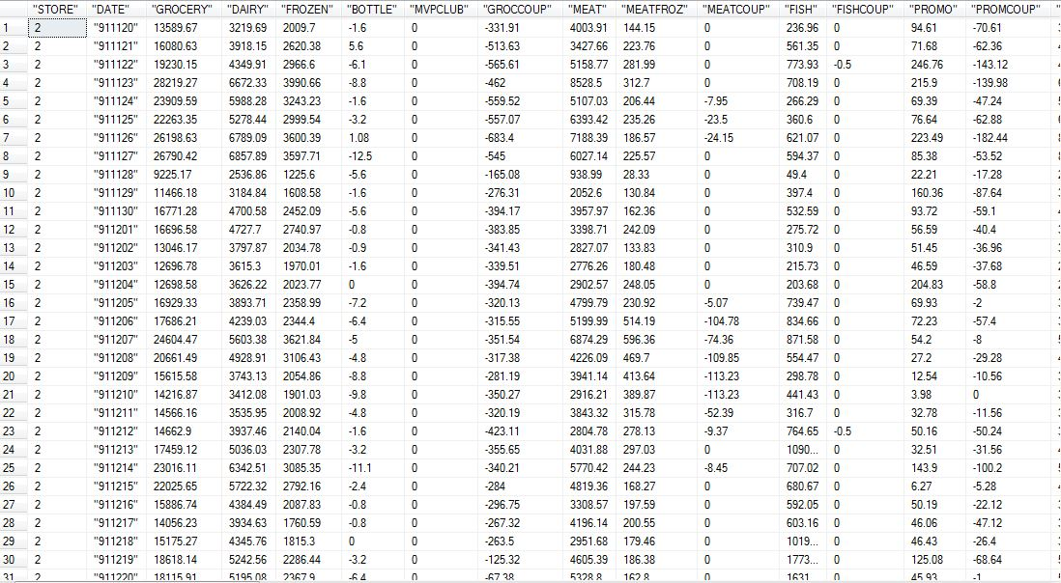

* The datatype of store IDs, Week and product category coupon redeemed values have been changed from varchar to int during extraction.
* The DEMO table is being extracted from demo.csv. The rows with non-numeric Store IDs have been cleaned during extraction process.
* While extracting data for demo table, junk data with missing MMIDs, which uniquely identify each demo row, have been cleaned.

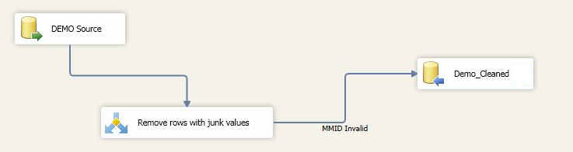

* The columns below_9_%, above_60_% and poor_% have been converted from varchar to numeric.
* The data in UPC table is being extracted using Foreach Container for all UPCXXX.csv files and then combined into final table.

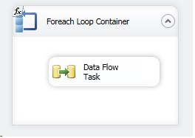

* In the cleaned UPC table we are mapping each row with product category. E.g. for data extracted from the file UPCANA.csv, product category is “ANA”. We are using following extraction expression to extract product category from file name.

*SUBSTRING(@[User::fileName],LEN(@[User::fileName]) - FINDSTRING(REVERSE(@[User::fileName]),"\\",1) + 2,LEN(RIGHT(@[User::fileName],FINDSTRING(REVERSE(@[User::fileName]),"\\",1) - 1)) - FINDSTRING(REVERSE(@[User::fileName]),".",1))*

* The data in Movement table is being extracted using Foreach Container for all movement csv files and then combined into final Movement table.

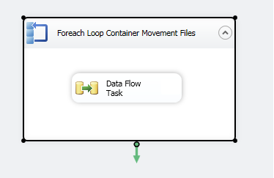

## Screenshots of Data Staging area

The extracted data from the data sources have been stored in the 601-Group11-Staging-Area database. The data from staging area will further be transformed for data marts. The screenshots of different tables in staging area are as follows:

**Table: 601-Group11-Staging-Area.CCOUNT**

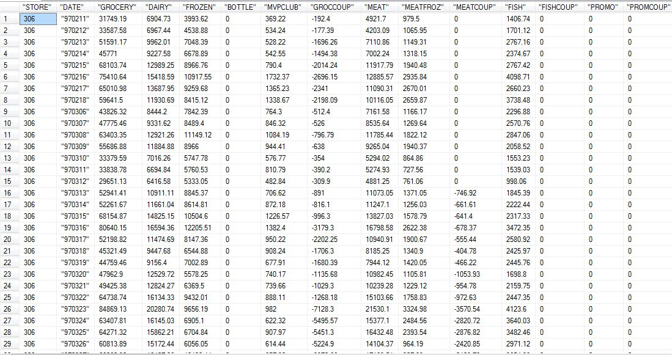

**Table: 601-Group11-Staging-Area.DEMO**

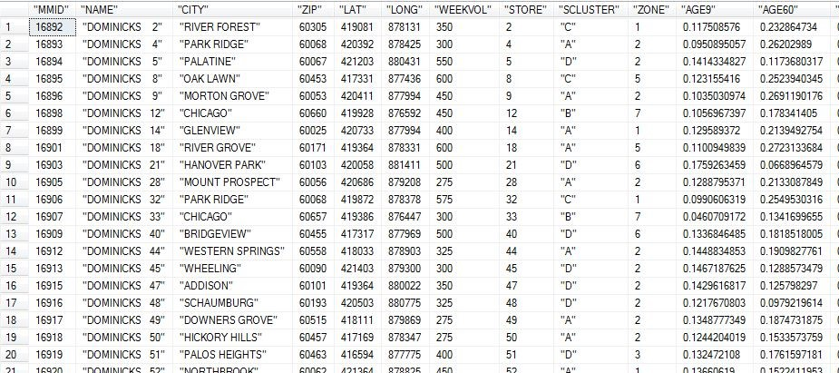

**Table: 601-Group11-Staging-Area.UPC**

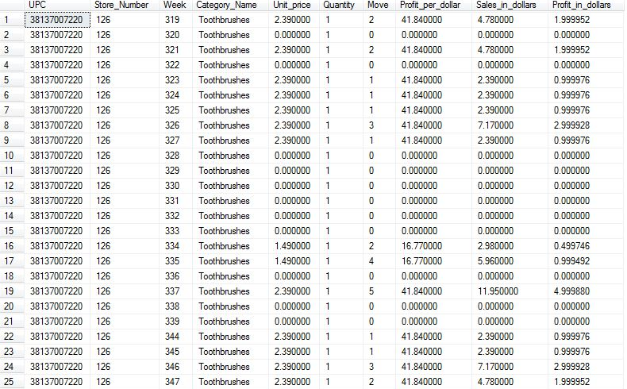

**Table: 601-Group11-Staging-Area.STORES**

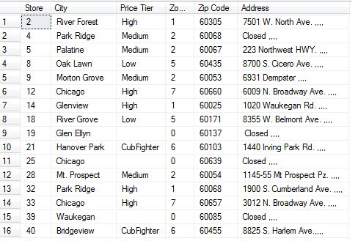

**Table: 601-Group11-Staging-Area.TIME**

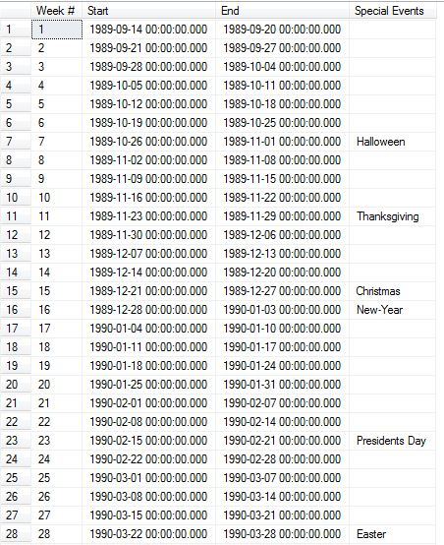

## Data Transformation and Cleansing Rules

1. **Transformation of INCOME in CCOUNT to INCOME_LEVEL**

Income column on CCOUNT tables stores log of median income (M.I.), which ranges from 9.87 to 11.24. e9.87=$19,341 and e11.24 = $76,114. We define 3 levels for INCOME_LEVEL:   
 *Low*: <10.3 (M.I. less than $30,000 )  
 *Medium*: 10.3 to 11.0(M.I. between $60,000)  
 *High*: >11.0 (M.I. greater than $60,000)

We have used following expression in SSIS to generate the income levels from income values in the DEMO table.

*INCOME_LEVEL = (INCOME > 11) ? "High" : (INCOME < 10.3 ? "Low" : "Medium")*

1. **Calculation of Sales Amount value from Price, Movement and Quality columns**

The sales amount for each row in Movement table in staging area has been calculated using following transformation.

*Sales_in_dollars = (Unit_Price*Move/Quantity)*

1. **Deriving Product_Category from UPCXXX.csv filepath**

We derived Product_Category from path of each UPCXXX.cvs file. For example, if full path a upc file is C:/folder/UPCANA.csv, we extracted the filename i.e. UPCANA.csv and then we further extracted product category as “ANA”. The expression used in derived column SSIS component is as follows:

*SUBSTRING(@[User::fileName],LEN(@[User::fileName]) - FINDSTRING(REVERSE(@[User::fileName]),"\\",1) + 2,LEN(RIGHT(@[User::fileName],FINDSTRING(REVERSE(@[User::fileName]),"\\",1) - 1)) - FINDSTRING(REVERSE(@[User::fileName]),".",1))*

1. **Transformation of Time data into Week, Month and Year details**

We used Week’s Decode Table for this transformation.

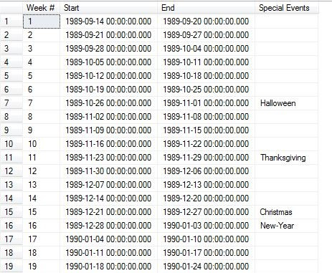

For this transformation, we converted start date for each week from varchar to datetime datatype and then derived Month and Year value from the data using following SSIS expressions.

*YEAR = YEAR([Datatype convert for Week].Start)*

*MONTH = MONTH([Datatype convert for Week].Start)*

## Plan for Aggregation

Aggregation is done in Coupon dimension table, Sales fact table and Store Visits fact table for answering the business questions and to fix the granularity. Please find the explanation for each aggregation below.

1. **Aggregation in Coupon dimension table**.

Coupon redeemed data is loaded from CCount table and the data is aggregated on weekly basis to keep the time granularity of the Coupon redeemed sales at Weekly level. As shown in figure below Coupon redeemed attribute in Coupon dimension table is calculated by summing up the Coupon redeemed value on a weekly basis. Hence the surrogate keys generated for Coupon dimension in in one-to-one mapping with week number.

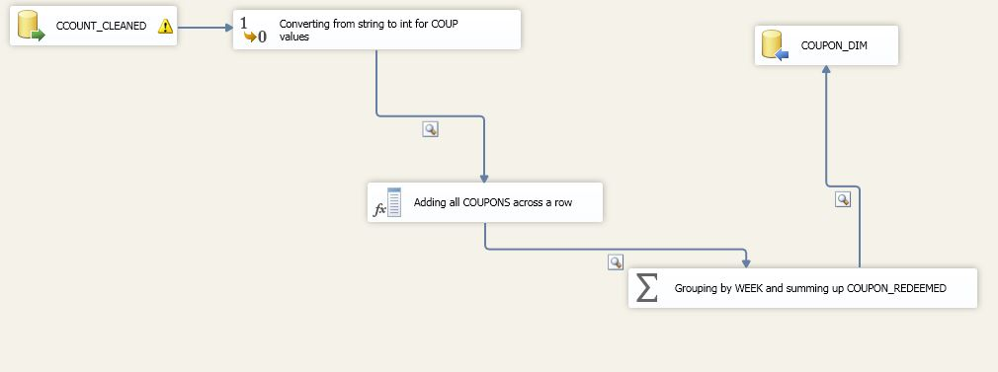

1. **Aggregation in SALES_FACT table.**

Source data for Sales fact table is Movement table .lookup transformation is performed with cleaned Movement table from data staging area on Time, Store and Product dimension tables on the matching of attributes Week Number, Store Number and UPC Code with respective tables. Aggregation of the MOVEMENT, QUANTITY and SALES_AMOUNT in the resultant table is aggregated on the basis of Store_ID, Time_ID and Product_ID. Store_ID, Time_ID and Product_ID are mapped to Store Number, Week Number and UPC_Code respectively. So the aggregation ensures the granularity in the above levels for each dimensions. We are concerned mainly about the Time granularity for drilling down and rolling up in later phases of the project and the time granularity will be on Week level. This can be rolled up to Month and Year.

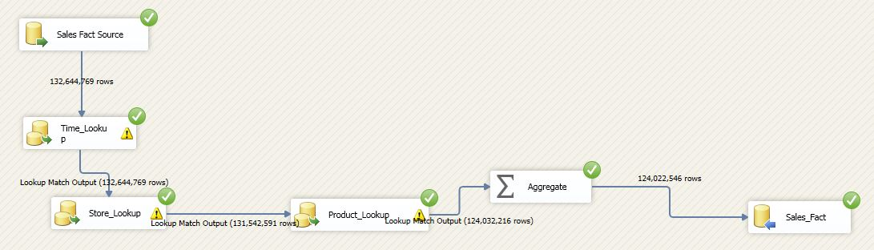

1. **Aggregation in STORE_VISITS_FACT table.**

Source data for the STORE_VISITS_FACT table is the CCount data. Lookup transformation was performed with cleaned CCount table from the staging area on STORE_DIM, TIME_DIM, DEMOGRAPHIC_DIM and COUPON_DIM tables in the same order as shown in the below figure. Attributes matched for lookup in STORE_DIM, TIME_DIM, DEMOGRAPHIC_DIM and COUPON_DIM tables are STORE_ID, TIME_ID,DEMO_ID and COUPON_ID respectively. Time granularity for the CUSTOMER_COUNT in the STORE_VISITS_FACT is WEEK .This can be rolled up to Month and Year level.

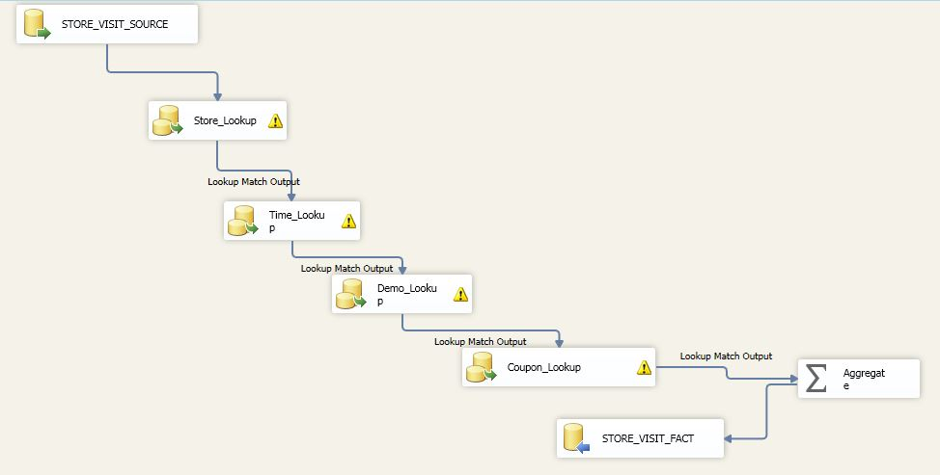

# Data Loading

Main source of data for this project is main from 4 .csv files- CCount, Demographics, UPC and Movement. This data was directly loaded into data staging area of the warehouse directly and data cleaning operations were performed as explained in this report. This cleaned data was further transformed using different ETL processes as explained below for the 5 final dimension(STORE_DIM, PRODUCT_DIM,TIME_DIM, COUPON_DIM, DEMOGRAPHICS_DIM) tables and 2(SALES_FACT, STORE_VISITS_FACT) fact tables.

1. **ETL for DIMENSION tables**

**STORE_DIM**

Source data for the STORE_DIM is Dominick’s Stores data table. This data was cleaned and ETL was performed on it as shown in the below diagram. Few Column’s had no Zone value in Dominick Stores table and then data conversion was performed on it from String to Integer. This transformed data was stored in STORE_DIM table.

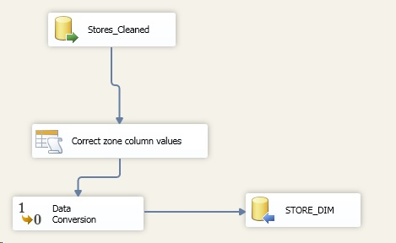

**PRODUCT_DIM**

Product Dimension tables took source data from UPC tables in Dominick’s data. Each product has its own UPC tables and all tables were merged together. This table was cleaned as explained previously. On the cleaned UPC data, data conversion was performed for ITEM_Code to convert from Varchar to Integer as shown below.

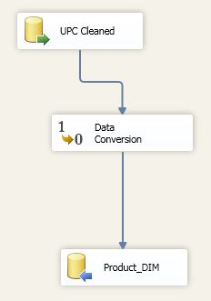

**TIME_DIM**

Weeks Decode table from Dominick’s manual acts as the source table for the TIME_DIM table. Initially the data type for Week is Varchar and it is converted to Integer. Thereafter the Month and Year attributes in TIME_DIM was derived from the date as per the Transformation described previously. This final transformed table is stored in TIME_DIM.

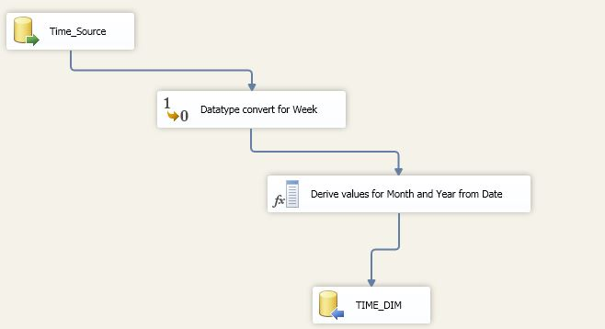

**COUPON_DIM**

Coupon redeemed values for the COUPON_DIM was sourced from CCount table. ETL is performed on the cleaned CCount table in data staging area. First of all data conversion from varchar to Integer was performed on Coupon redeemed values. Thereafter is performed on the Coupon redeemed values on weekly basis to get the weekly coupon redeemed values every week. This transformed table is kept COUPON_DIM table.



**DEMOGRAPHICS_DIM**

Demographics table from Dominick’s is the source table for DEMOGRAPHICS_DIM. The cleaned data is kept in data staging area and ETL transformation performed on the same. Firstly the values BELOW_9_% and ABOVE_60_% undergoes data type conversion from varchar to float. There after derived column INCOME_LEVEL is set as per the range of log of median income. Business rule for the same is explained in the mapping table. This will be the second stage of ETL transformation and the resultant table after this step is stored in DEMO_DIM.

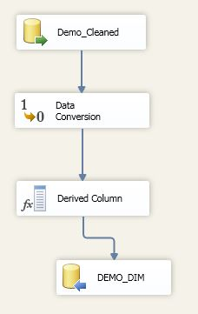

1. **ETL for FACT tables**

**SALES_FACT**

Movement table is the source data for Sales fact table. SALES_AMOUNT in Movement table is the value derived from Price, Quantity and Movement values in Movement table. Cleaning was performed on this table and kept in Staging area. Lookup transformation was performed on this table this table as source on TIME_DIM, STORE_DIM, PRODUCT_DIM and aggregation was performed as explained previously before loading the data in SALES_FACT table.



**STORE_VISITS_FACT**

Source data for STORE_VISITS_FACT table is CCount table. Cleaned CCount data in staging area undergoes Lookup transformation with STORE_DIM, TIME_DIM, DEMO_DIM and COUPON _DIM. Finally aggregation is performed as explained previously and final data is loaded in STORE_VISITS_FACT table.



## Mapping definition describing the source to end table for all dimension and fact tables

End to end mapping of elements from source to destination data marts

|  |  |  |  |  |  |  |  |  |
| --- | --- | --- | --- | --- | --- | --- | --- | --- |
| **Dimension: Product** | | | | | | | | |
| **Source File** | **Column Name** | **Datatype** | **Staging Table** | **Staging Column** | **Staging Column Datatype** | **Production Table** | **Production Column** | **Production Column Datatype** |
| UPC.csv | UPC_CODE | varchar | UPC-Cleaned | UPC | varchar | PRODUCT_DIM | UPC_CODE | int |
| PRODUCT_CATEGORY | varchar | PROD_CATEGORY | varchar | PRODUCT_CATEOGRY | varchar |
| ITEM_CODE | varchar | NITEM | varchar | ITEM_CODE | int |

|  |  |  |  |  |  |  |  |  |
| --- | --- | --- | --- | --- | --- | --- | --- | --- |
| **Dimension: Store** | | | | | | | | |
| **Source File** | **Column Name** | **Datatype** | **Staging Table** | **Staging Column** | **Staging Column Datatype** | **Production Table** | **Production Column** | **Production Column Datatype** |
| Demo.csv | STORE | varchar | Stores-Cleaned | STORE | int | STORE_DIM | STORE_NUMBER | int |
| PRICE TIER | varchar | PRICE TIER | varchar | PRICE_TIER | varchar |
| ZONE | varchar | ZONE | varchar | ZONE | int |
| CITY | varchar | CITY | varchar | CITY | varchar |
| ZIPCODE | varchar | ZIPCODE | varchar | ZIPCODE | varchar |

|  |  |  |  |  |  |  |  |  |
| --- | --- | --- | --- | --- | --- | --- | --- | --- |
| **Dimension: Time** | | | | | | | | |
| **Source File** | **Column Name** | **Datatype** | **Staging Table** | **Staging Column** | **Staging Column Datatype** | **Production Table** | **Production Column** | **Production Column Datatype** |
| Dominick's Stores | Week # | varchar | Time-Cleaned | Week # | int | TIME_DIM | WEEK | int |
| Start | varchar | Start | Datetime | MONTH | Calculated Field |
| End | varchar | End | Datetime | YEAR | Calculated Field |
| Special Events | varchar | Special Events | varchar | SPECIAL EVENTS | varchar |

|  |  |  |  |  |  |  |  |  |
| --- | --- | --- | --- | --- | --- | --- | --- | --- |
| **Dimension: Demographic** | | | | | | | | |
| **Source File** | **Column Name** | **Datatype** | **Staging Table** | **Staging Column** | **Staging Column Datatype** | **Production Table** | **Production Column** | **Production Column Datatype** |
| Demo.csv | Age9 | varchar | DEMO-Cleaned | BELOW_9_% | varchar | DEMOGRAPHIC_DIM | BELOW_9_% | decimal |
| age60 | varchar | ABOVE_60_% | varchar | ABOVE_60_% | decimal |
| poverty | varchar | POOR_% | varchar | POOR_% | decimal |
| income | varchar | INCOME_LEVEL | decimal | INCOME_LEVEL | Calculated Value |
| Store | varchar | STORE_NUM | int | STORE_NUM | int |

|  |  |  |  |  |  |  |  |  |
| --- | --- | --- | --- | --- | --- | --- | --- | --- |
| **Dimension: Coupon** | | | | | | | | |
| **Source File** | **Column Name** | **Datatype** | **Staging Table** | **Staging Column** | **Staging Column Datatype** | **Production Table** | **Production Column** | **Production Column Datatype** |
| CCOUNT.csv | Coupon Redeemed | Coupon value across the different products- Calculated field | CCOUNT-Cleaned | COUPON_REDEEMED | decimal | COUPON_DIM | COUPON_REDEEMED | varchar |

|  |  |  |  |  |  |  |  |  |
| --- | --- | --- | --- | --- | --- | --- | --- | --- |
| **Fact Table: Sales** | | | | | | | | |
| **Source File** | **Column Name** | **Datatype** | **Staging Table** | **Staging Column** | **Staging Column Datatype** | **Production Table** | **Production Column** | **Production Column Datatype** |
| Keys are auto incremented values | | | PRODUCT_DIM | PRODUCT_ID | int | SALES_FACT | PRODUCT_ID | int |
| STORE_DIM | STORE_ID | int | STORE_ID | int |
| TIME_DIM | TIME_ID | int | TIME_ID | int |
| UPC.csv | move | varchar | UPC-Cleaned | movement | int | MOVEMENT | int |
| UPC.csv | qty | varchar | UPC-Cleaned | quantity | int | QUANTITY | decimal |
| UPC.csv | Sales | Calculated value | UPC-Cleaned | Sales amount | decimal | SALES_AMOUNT | decimal |

|  |  |  |  |  |  |  |  |  |
| --- | --- | --- | --- | --- | --- | --- | --- | --- |
| **Fact Table: Store visits** | | | | | | | | |
| **Source File** | **Column Name** | **Datatype** | **Staging Table** | **Staging Column** | **Staging Column Datatype** | **Production Table** | **Production Column** | **Production Column Datatype** |
| Keys are auto incremented values | | | DEMOGRAPHIC_DIM | DEMO_ID | int | STORE_VISITS_FACT | DEMO_ID | int |
| COUPON_DIM | COUPON_ID | int | COUPON_ID | int |
| STORE_DIM | STORE_ID | int | STORE_ID | int |
| TIME_DIM | TIME_ID | int | TIME_ID | int |
| CCOUNT.csv | CUSTCOUN | varchar | CCOUNT-Cleaned | Customer Count | int | COUSTOMER_COUNT | int |

## SQL statements used for the ETL operations

Below are the SQL scripts used to create the destination tables:

CREATE TABLE [dbo].[COUPON_DIM](

[COUPON_ID] [int] NOT NULL,

[COUPON_REDEEMED] [real] NULL,

PRIMARY KEY [COUPON_ID]

)

CREATE TABLE [dbo].[DEMOGRAPHIC_DIM](

[DEMO_ID] [int] IDENTITY(1,1) NOT NULL,

[BELOW_9_%] [numeric](10, 2) NULL,

[ABOVE_60_%] [numeric](10, 2) NULL,

[POOR_%] [numeric](10, 2) NULL,

[INCOME_LEVEL] [varchar](50) NULL,

[STORE_NUM] [int] NOT NULL,

PRIMARY KEY [DEMO_ID]

)

CREATE TABLE [dbo].[PRODUCT_DIM](

[PRODUCT_ID] [int] IDENTITY(1,1) NOT NULL,

[UPC_CODE] [varchar](50) NULL,

[PRODUCT_CATEGORY] [varchar](50) NULL,

[ITEM_CODE] [varchar](50) NULL,

PRIMARY KEY [PRODUCT_ID]

)

CREATE TABLE [dbo].[STORE_DIM](

[STORE_ID] [int] IDENTITY(1,1) NOT NULL,

[STORE_NUMBER] [int] NULL,

[PRICE_TIER] [varchar](50) NULL,

[ZONE] [int] NULL,

[CITY] [varchar](50) NULL,

[ZIPCODE] [varchar](50) NULL,

PRIMARY KEY [STORE_ID]

)

CREATE TABLE [dbo].[TIME_DIM](

[TIME_ID] [int] IDENTITY(1,1) NOT NULL,

[WEEK] [int] NULL,

[MONTH] [int] NULL,

[YEAR] [int] NULL,

[EVENTS] [varchar](50) NULL,

PRIMARY KEY [TIME_ID]

)

CREATE TABLE [STORE_VISITS_FACT] (

DEMO_ID int FOREIGN KEY references DEMOGRAPHIC_DIM(DEMO_ID),

COUPON_ID int FOREIGN KEY references COUPON_DIM(COUPON_ID),

STORE_ID int FOREIGN KEY references STORE_DIM(STORE_ID),

TIME_ID int FOREIGN KEY references TIME_DIM(TIME_ID),

COSTOMER_COUNT int

PRIMARY KEY (DEMO_ID,COUPON_ID,STORE_ID,TIME_ID)

)

CREATE TABLE [SALES_FACT] (

PRODUCT_ID int FOREIGN KEY references PRODUCT_DIM(PRODUCT_ID),

STORE_ID int FOREIGN KEY references STORE_DIM(STORE_ID),

TIME_ID int FOREIGN KEY references TIME_DIM(TIME_ID),

MOVEMENT int,

QUANTITY int,

SALES_AMOUNT numeric,

PRIMARY KEY (PRODUCT_ID,STORE_ID,TIME_ID)

)

## Staging and Data Mart table screen shots

**Staging tables:**

601-Group11-Staging-Area.CCOUNT-Cleaned



601-Group11-Staging-Area.DEMO-Cleaned

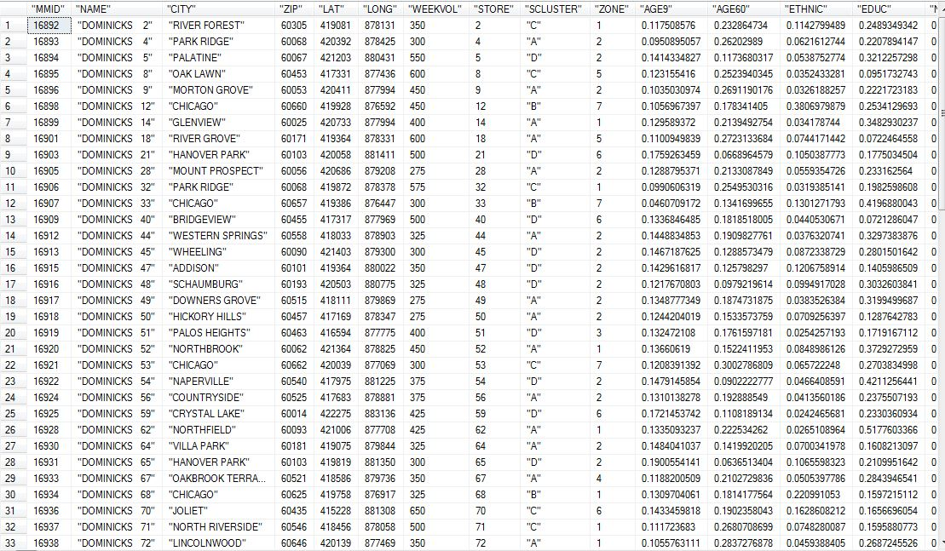

601-Group11-Staging-Area.MOVEMENT-Cleaned

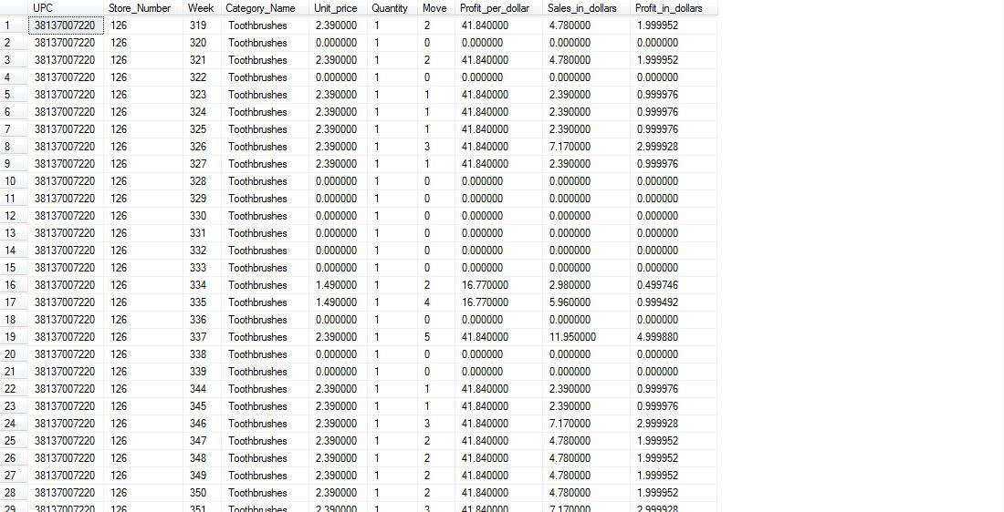

601-Group11-Staging-Area.STORES-Cleaned

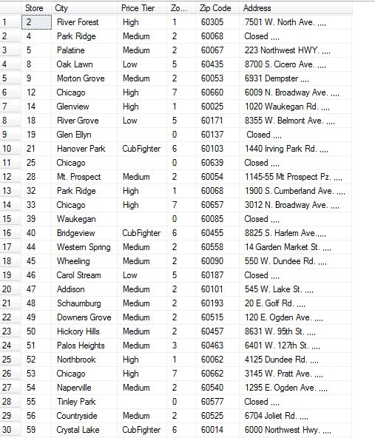

601-Group11-Staging-Area.TIME-Cleaned

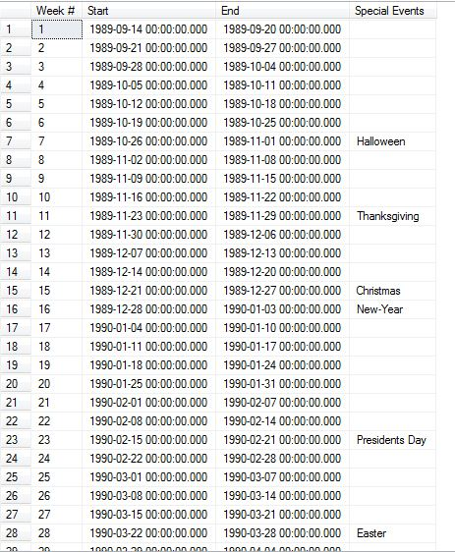

601-Group11-Staging-Area.UPC-Cleaned

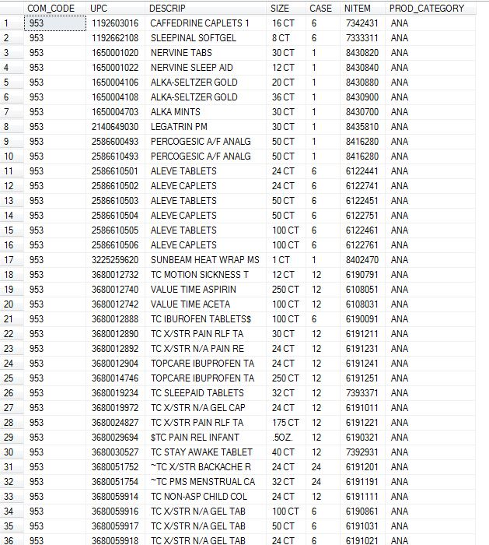

**Data Mart tables:**

601-Group11-DW-Area.PRODUCT_DIM

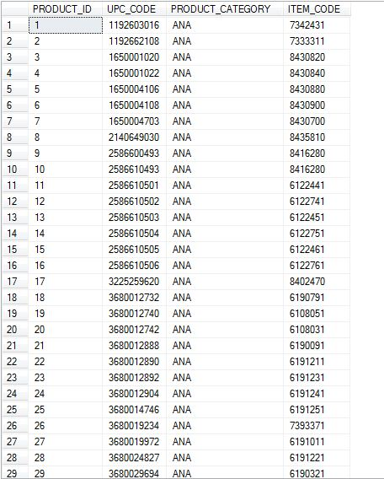

601-Group11-DW-Area.TIME_DIM

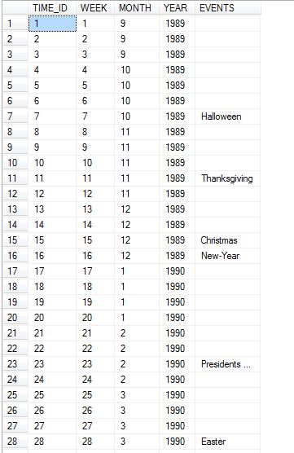

601-Group11-DW-Area.STORE_DIM

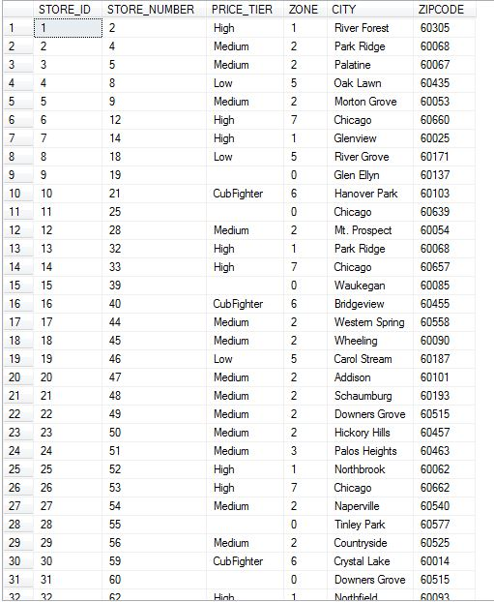

601-Group11-DW-Area.DEMOGRAPHIC_DIM

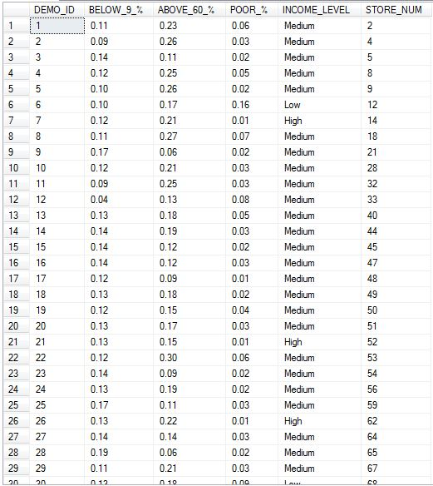

601-Group11-DW-Area.COUPON_DIM

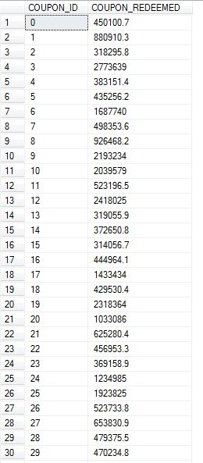

601-Group11-DW-Area.STORE_VISITS_FACT

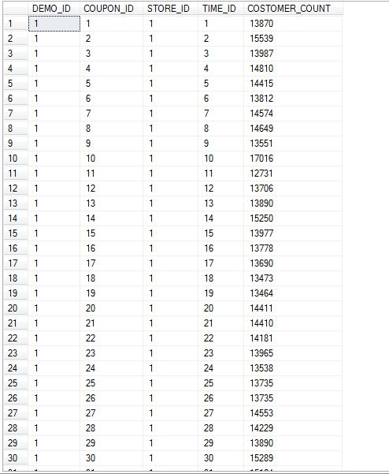

601-Group11-DW-Area.SALES_FACT

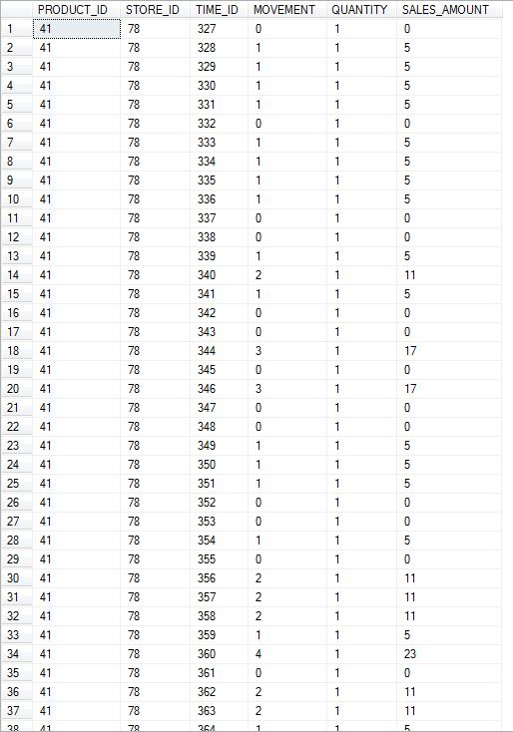

# **BI reporting**

# BI Reports Design and Implementation

## Reporting plan

For our reporting and analysis, we have used SSRS, SSAS, ReportBuilder 3.0, SSRS on top of SSAS. Following is our reporting strategy.

|  |  |
| --- | --- |
| Business Question 1 | SSAS + SSRS |
| Business Question 2 | SSRS |
| Business Question 3 | Report Builder 3.0 |
| Business Question 4 | Report Builder 3.0 |
| Business Question 5 | SSAS |

### Determining all target reports that satisfy business questions

**Question1: What is the trend of Beer sales during Christmas holiday season?**

*Report generated from SSRS on top of SSAS*

We decided to create a cube using SALES_FACT fact table and added the attributes of Week, Product Category, Sales Amount and Event from TIME_DIM and PRODUCT_DIM dimension tables. We decided to use this plan because SALES_FACT has the largest size in the entire data warehouse and a cube created from it could be used to answer business Question 5 as well. Creating a cube added flexibility to our analysis and then allowed report easily using SSRS on top of the cube we created. We used line graph for data visualization since it was required to understand the trend.

**Question 2: Which stores have more popularity among kids and elderly groups?**

*Report generated from SSRS alone*

To solve this question, we used STORE_VISITS_FACT, DEMOGRAPHIC_DIM and STORE_DIM tables to generate the reports. Since we needed only two separate list of popular stores, one representing popularity among kids and another among elderly people, we decided to go for SSRS alone for this business question. We used STORE_DIM for STORE_NUMBER attributes. The ABOVE_60_% and BELOW_9_% attributes have been extracted from DEMOGRAPHIC_DIM table. Since, we were interested in only top 10 results, we order by demographic percentages in descending order and picked top 10 store numbers.

**Question 3: Which stores attract people who earn below poverty line?**

*Report generated using Report Builder 3.0*

This business question required generating report with the list of stores that are popular among poor income group and we decided to user Report Builder 3.0. The report is based on number of customer visits in the stores, so we used STORE_VISITS_FACT. This fact table provided us stores numbers which could be linked with the attributes POOR_% available in DEMOGRAPHIC_DIM table. DEMO_ID key has been used to create inner join between the table. We were inters tested in most popular stores among poor income group, so order the results by POOR_% in descending order.

**Question 4: What is the effect of introducing coupons on total number of customer visits?**

*Report generated from Report Builder 3.0*

For this business question, we used independent data mart – Store Visits to answer this business question. We required a report that represented coupons redeemed weekly trend against week numbers and decided to use Report Builder 3.0. The COUPON_ID attribute has been used to join COUPON_DIM and STORE_VISITS_FACT to generate COUPON_REDEEMED attribute. The TIME_ID attribute has been used to join TIME_DIM and STORE_VISITS_FACT to generate WEEK attribute of the report. We aggregated COUPON_REDEEMED for each week to generate the trends and used bar graph for data visualization. We created another bar chart by aggregating customer visit counts per week. Comparing the trends of coupons redeemed per week and customer visits per week, we could analyze correlation between coupons redeemed and customer visits

**Question 5: What is the trend of a product demand in different price-tiers?**

*Analysis of the cube created from SSAS alone*

We analyze this business question using SSAS as we needed to use SALES_FACT fact table and creating a cube using this large table added flexibility to our analysis. This cube further used STORE_DIM and TIME_DIM for dimensions. The STORE_DIM provided attribute for price tiers (High, Low, Medium) and TIME_DIM provided week number attribute. We generated data using inner joins between the 3 tables and aggregated on weekly basis. We finally analyzed the cube using pivot chart.

## Mappings from the tables in the data marts to the attributes in the report

**Question1: What is the trend of beer sales during Christmas holiday season?**





**Question2: Which stores have more popularity among kids and elderly groups?**





**Question3: Which stores attract people who earn below poverty line?**

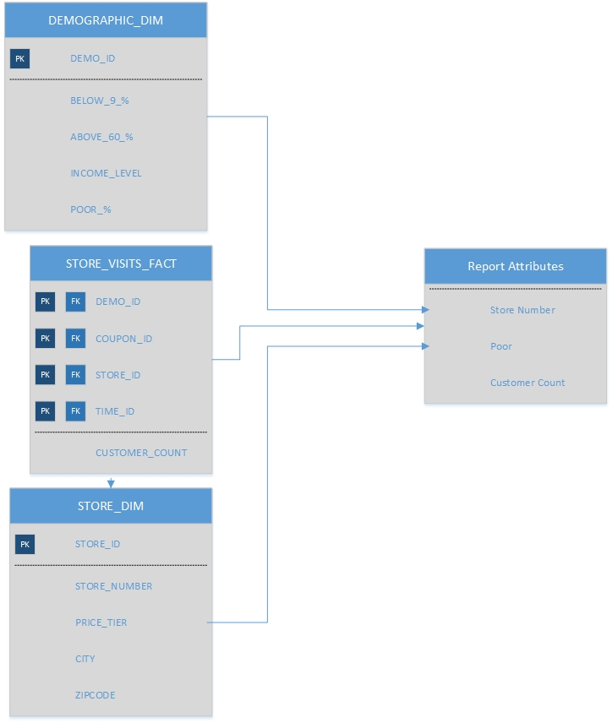

**Question4: What is the effect of introducing coupons on total number of customer visits?**







**Question5: What is the trend of a product demand in different price-tiers?**





## Cube from SSAS and Report from SSRS on top of SSAS for Question 1

As per the reporting plan described in previous part of report we are building the cube in SSAS and SSRS will be used on top of SSAS cube to generate report for question 1.

**Question 1:** What is the trend of Beer sales during Christmas holiday season?

**Designing Cube Using SSAS**

**Selecting Data Source for SSAS**

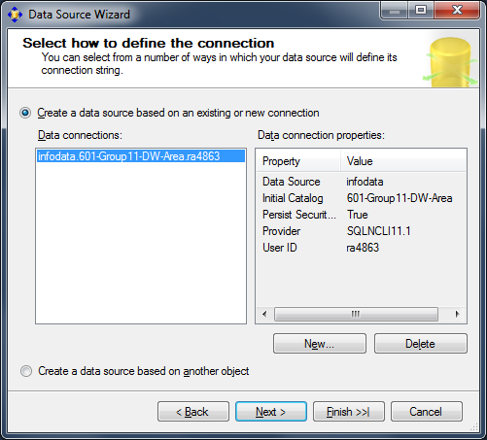

**Designing Data Source Views**

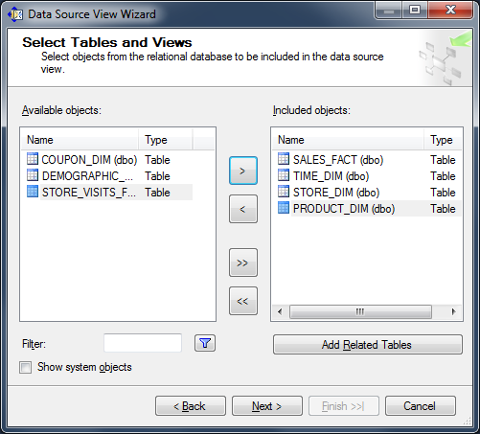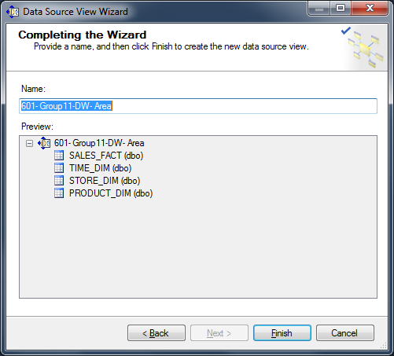

The data source view looks as follows.

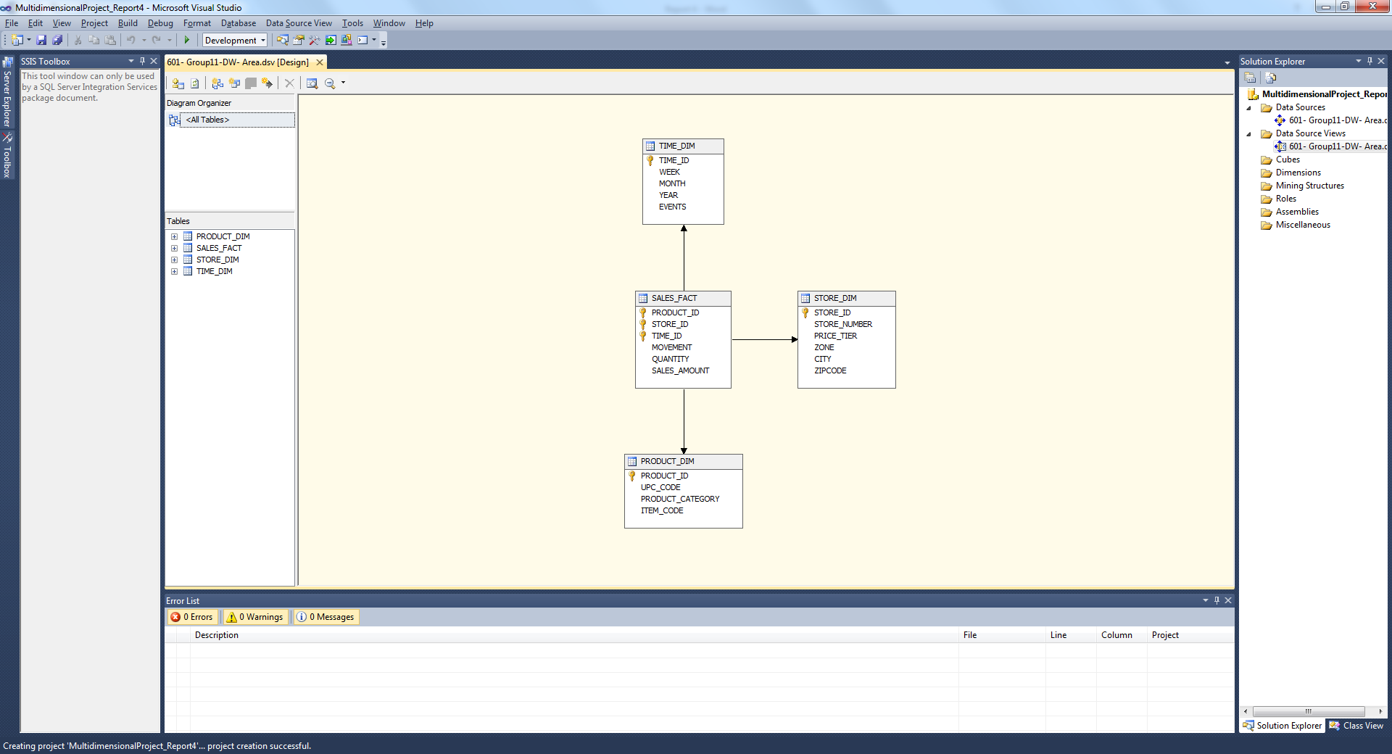

**Configuring SSAS Multidimensional Database**

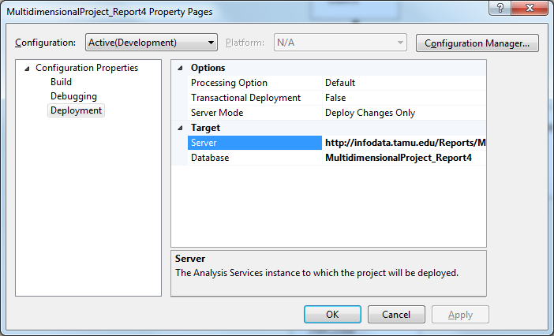

**Creating Cube from Data Source View**

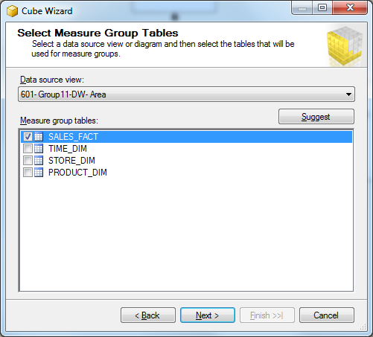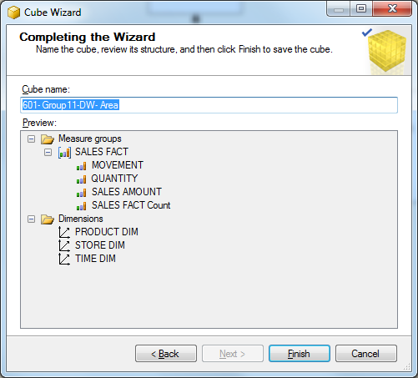

The cube appears as follows.

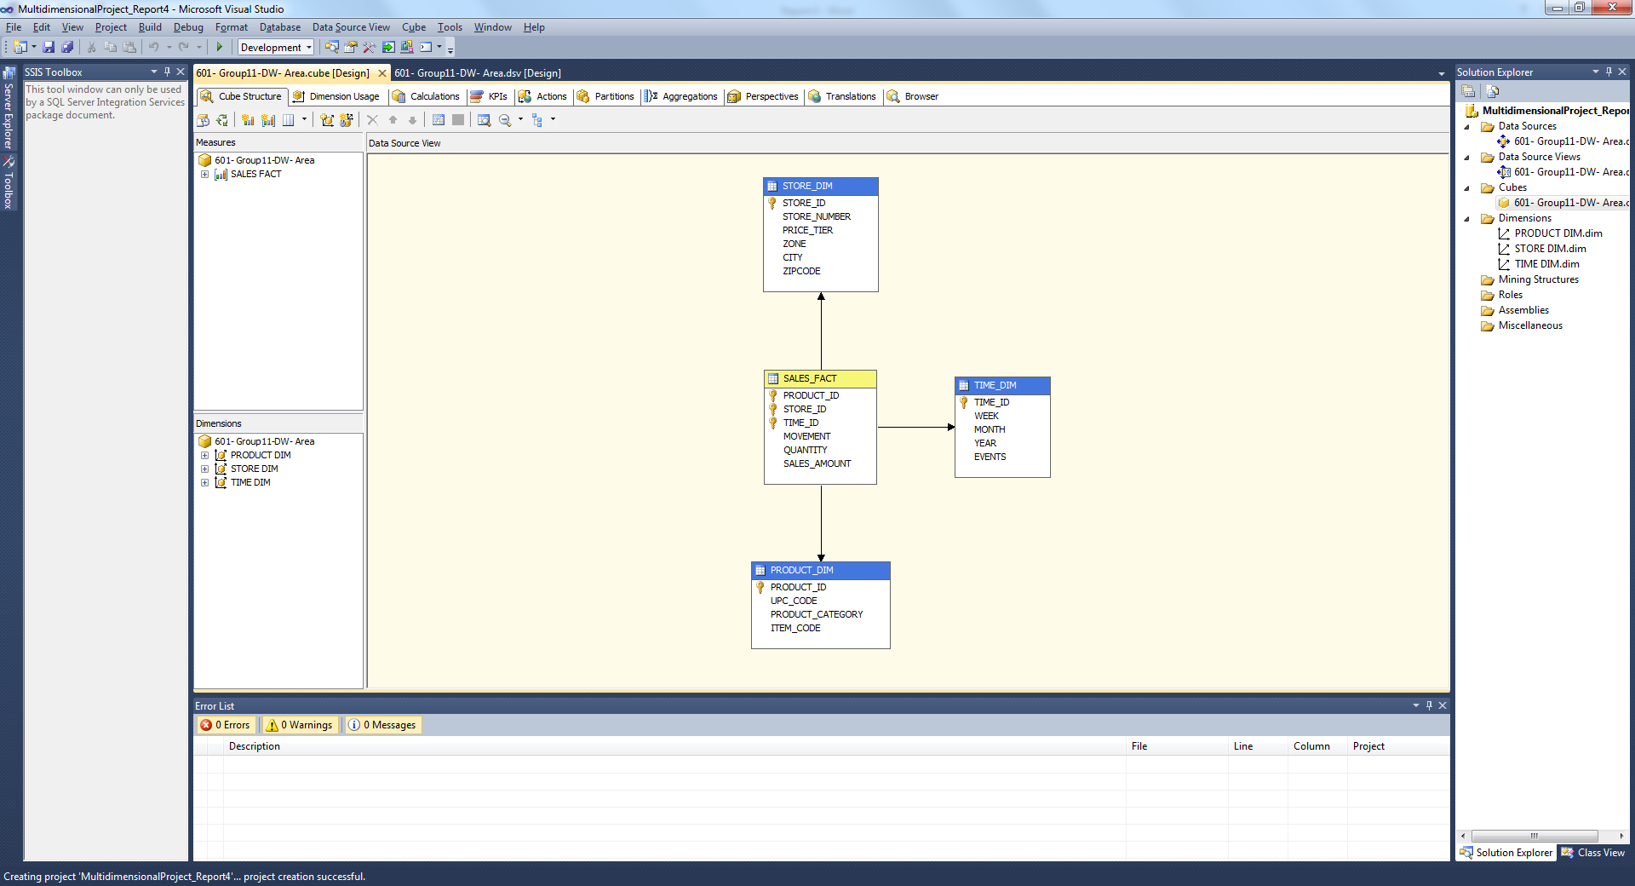

**Defining hierarchies for Time Dimension**

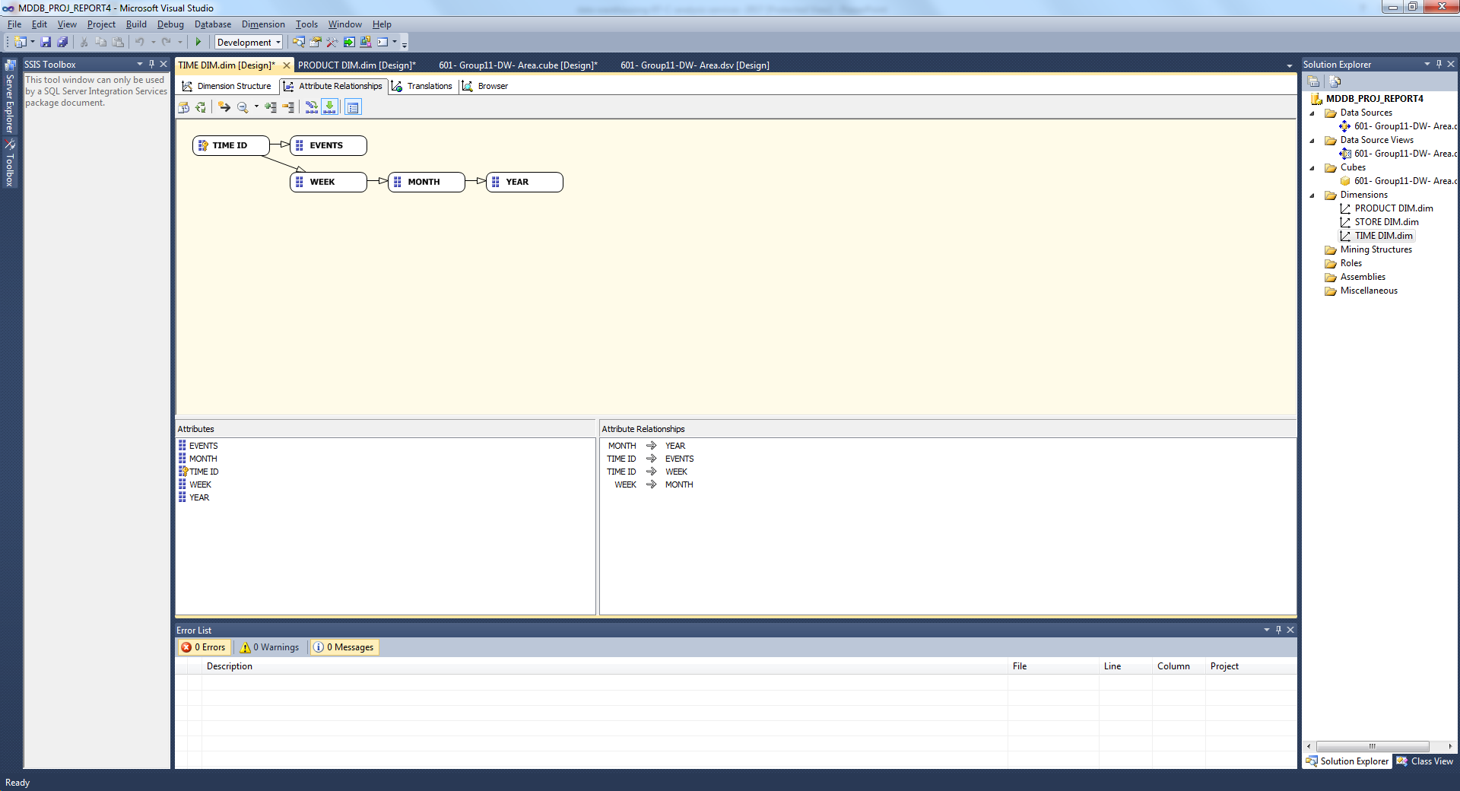

**Deploying SSAS Cube**

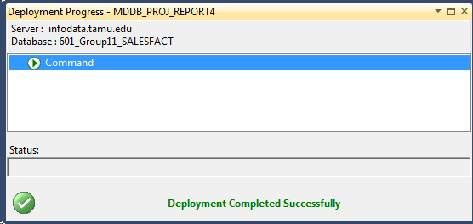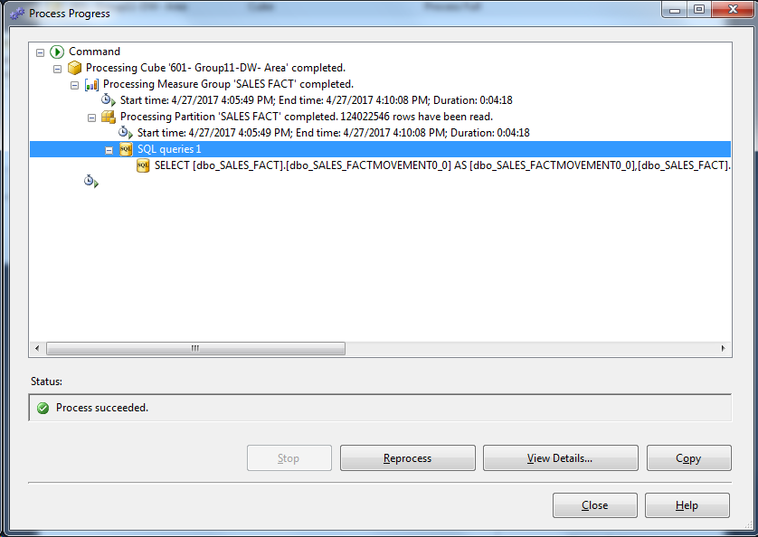

**Browsing the Deployed Cube**

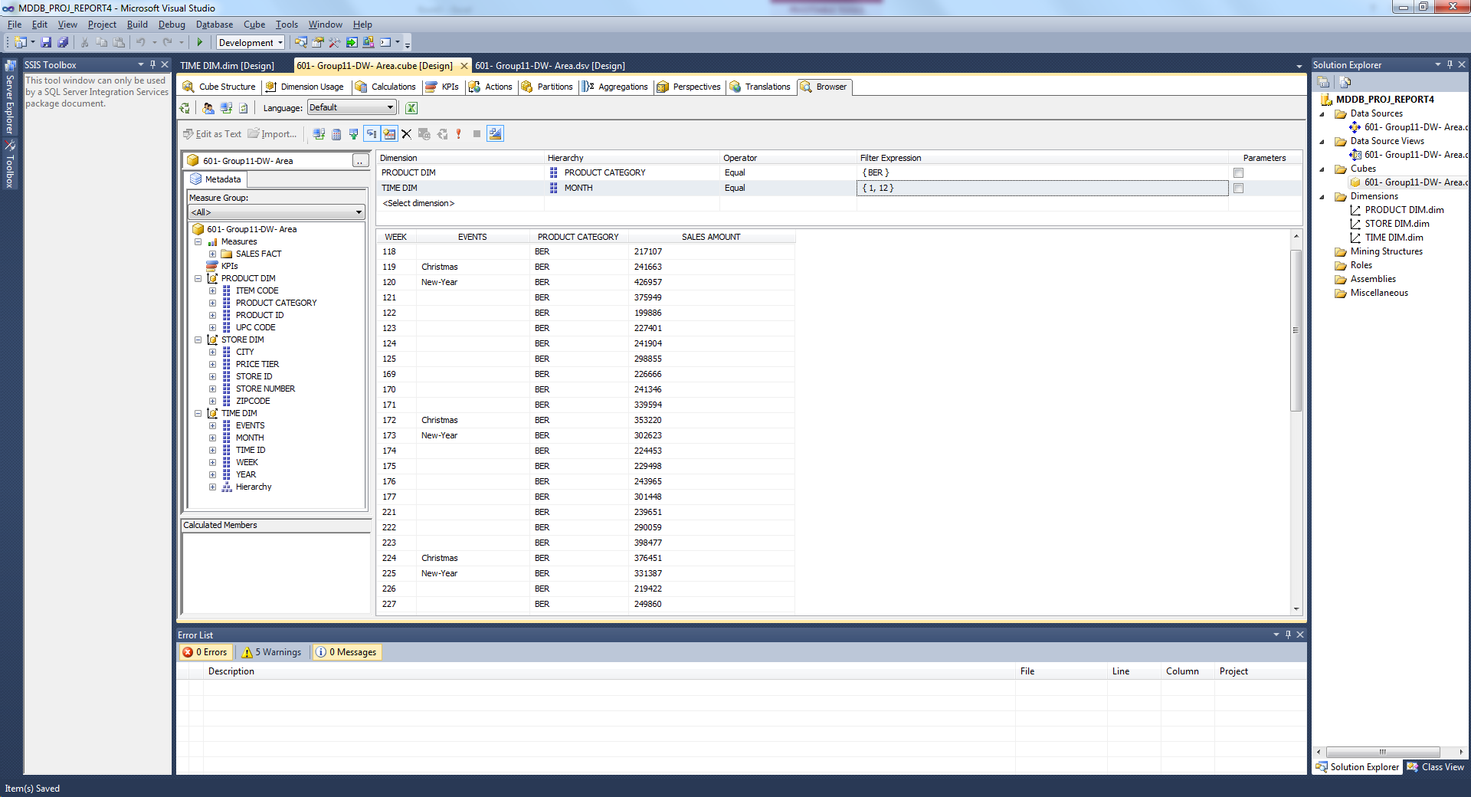

**SSRS Reporting on Top of SSAS for Question1.**

**Selecting data source as Cube deployed in previous step**

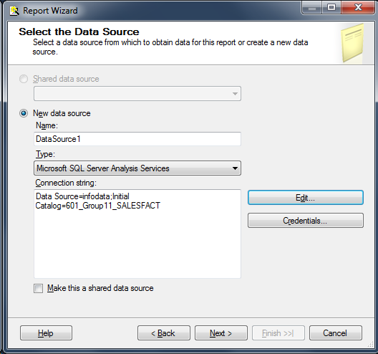

**Designing query for Report generation**

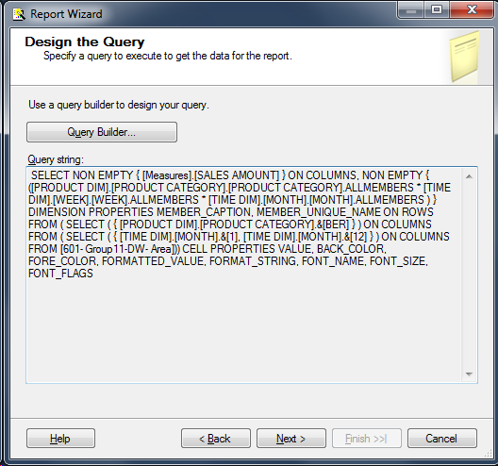

**Designing table for report**

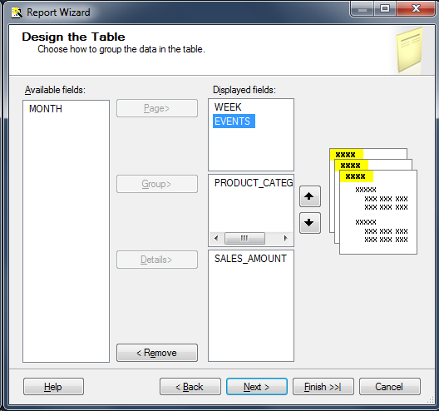

**Final Report deployed on the server**

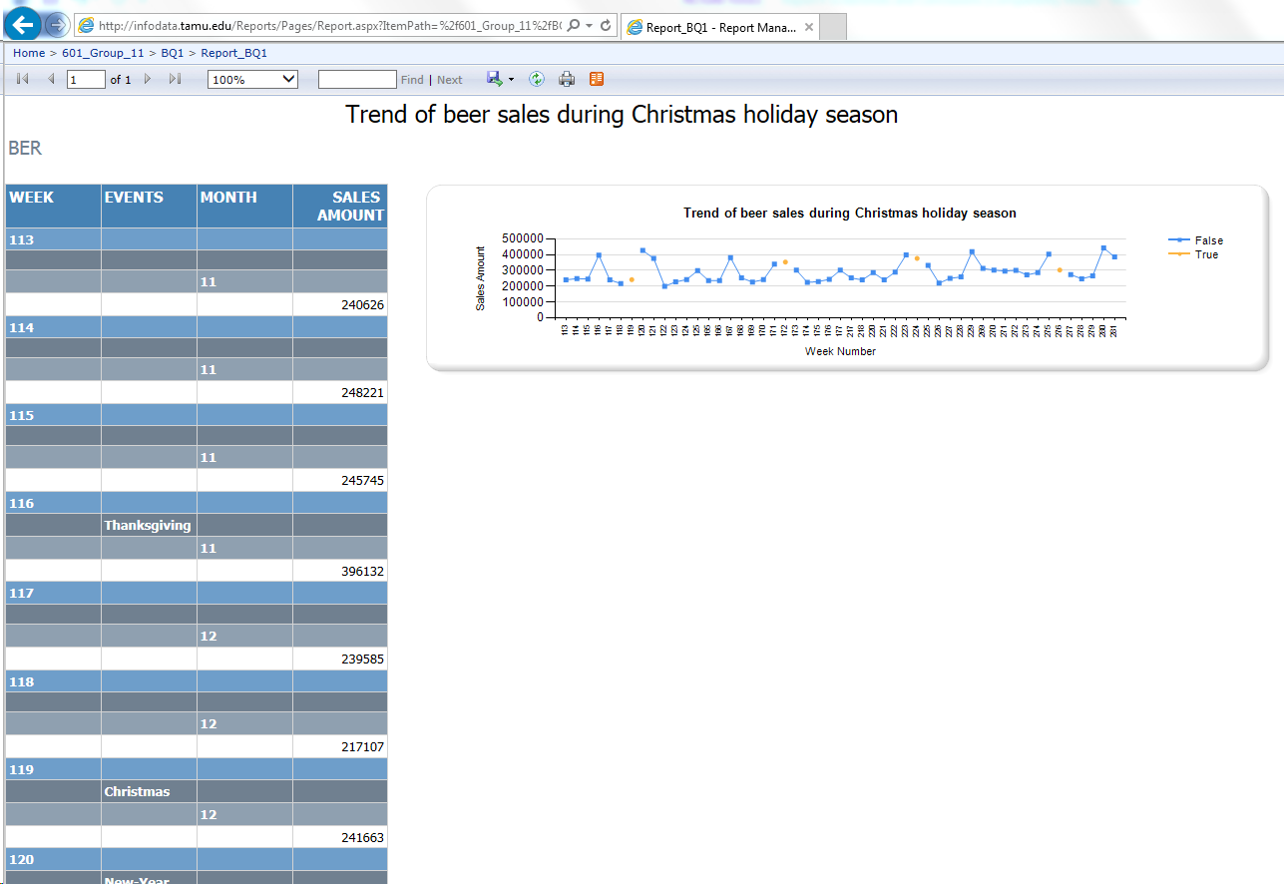

**Conclusion**

The above report plots the weekly sales of Beer in the month of November, December and January. From the graph, we get a clear idea about the trend of beer sales during the Christmas-New year holiday period. Also we can conclude that the Beer sales across the shops in Dominic Finer Food have several peaks in the months of November, December and January, even though the peak is not strictly during Christmas and New Year Weekends.

How the report assists the management:

This will give a clear direction to inventory team at DFF to store more Beer during the Christmas-New Year period. A similar approach can be used by Business Intelligence team at DFF for predicting the sales of different products during different festival season well ahead.

## SSRS Reporting from Independent Data Mart using for Question 2

As per the reporting plan described in previous parts we are generating a report on SSRS reporting tool for answering the question number 2.

**Question 2**: Which stores have more popularity among kids and elderly groups?

**Designing SSRS Report for Popularity among Kids**

**Selecting Data Source for SSRS**

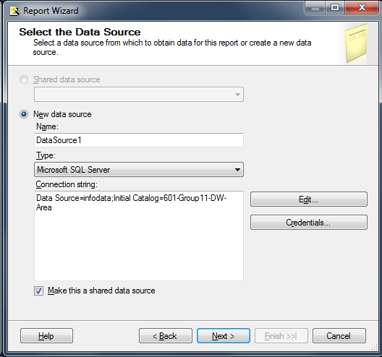

**Designing the query for SSRS report**

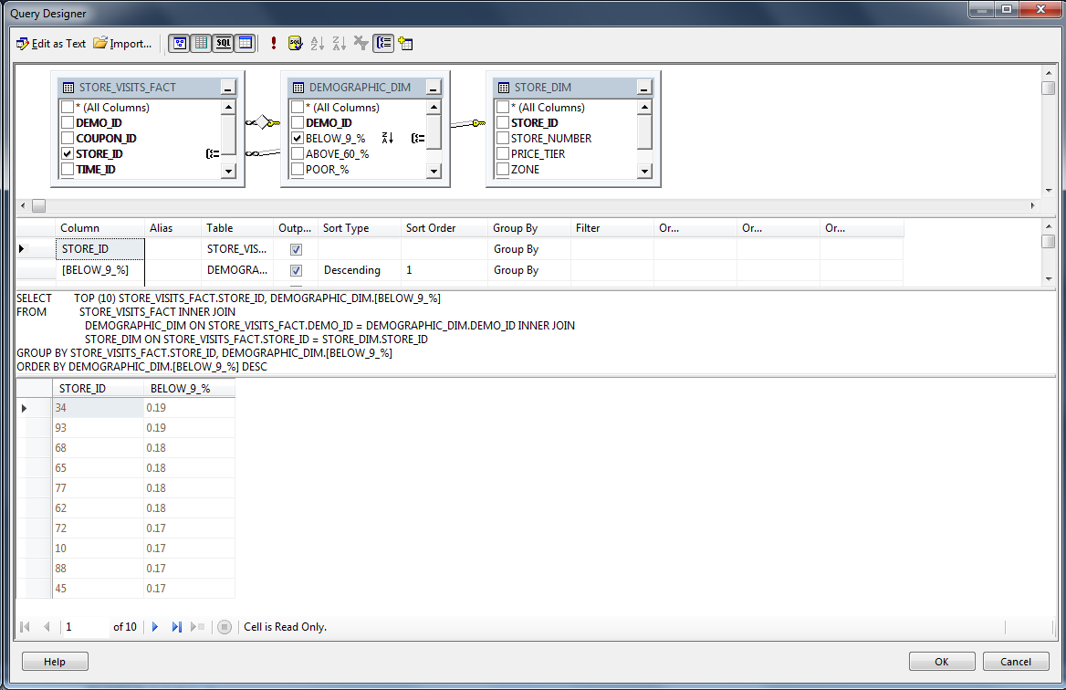

**Designing the table for SSRS Report**

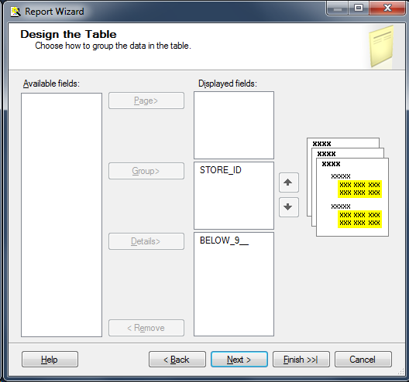

**Plotted Bar Graph for store popularity among kids**

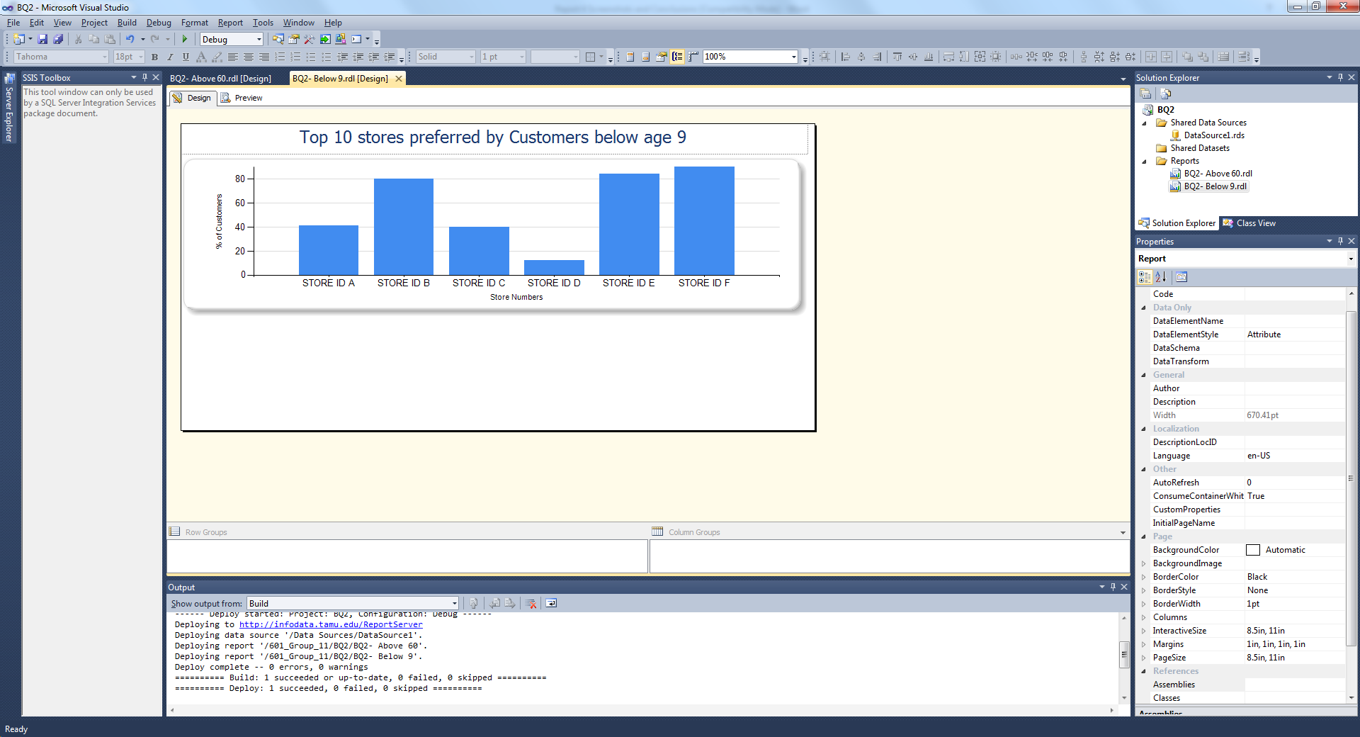

**Browsing Report Deployed on the server**

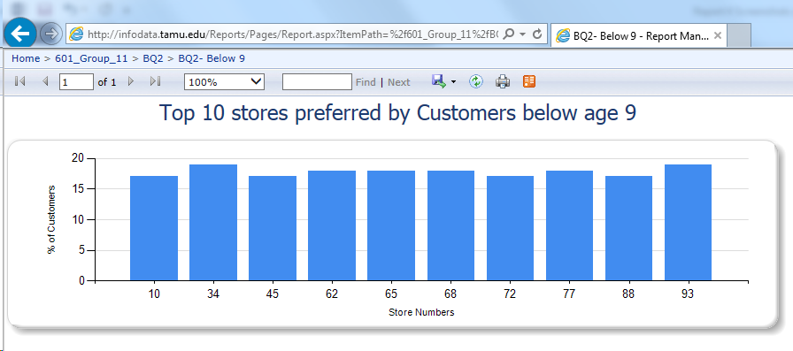

**Designing SSRS Report for Popularity Among Elderly Customers**

**Designing Query for plotting Store popularity among elderly group**

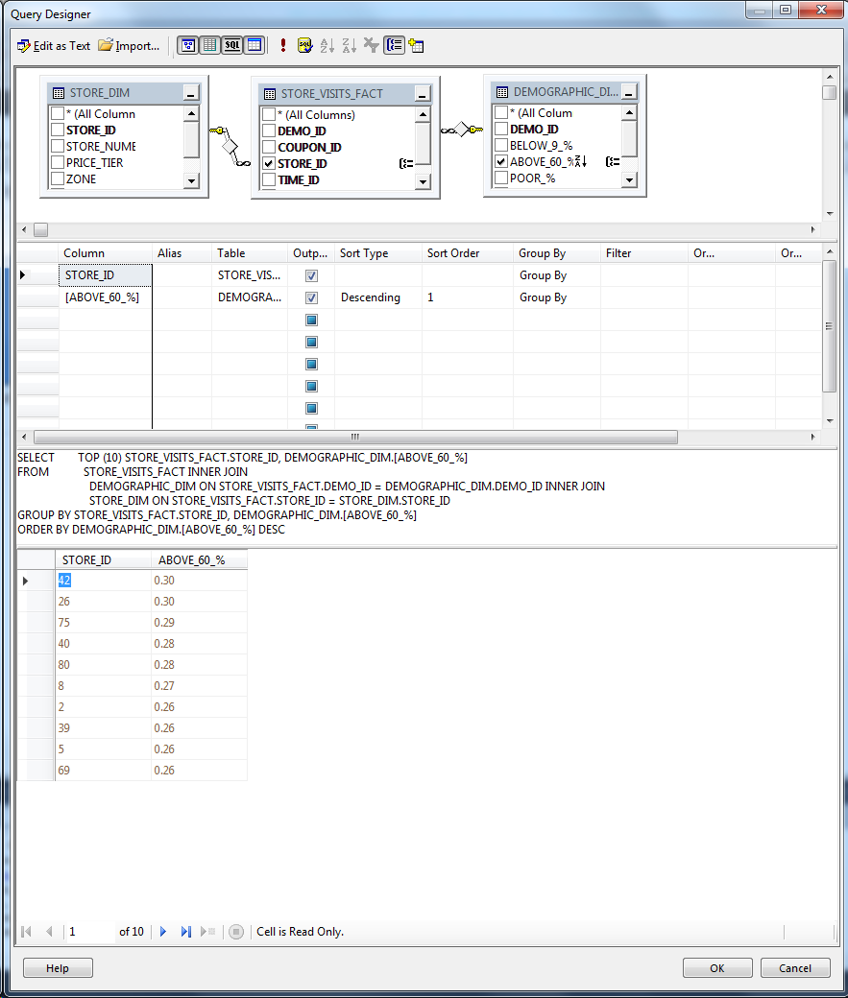

**Designing Table for Report**

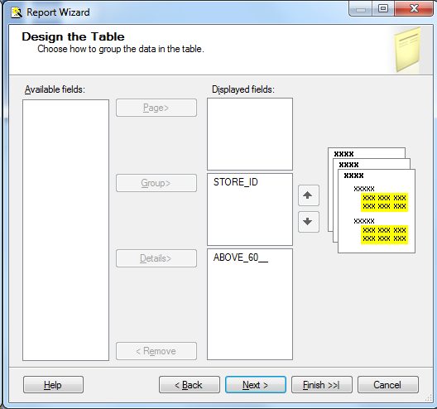

**Screenshot of report in the design view**

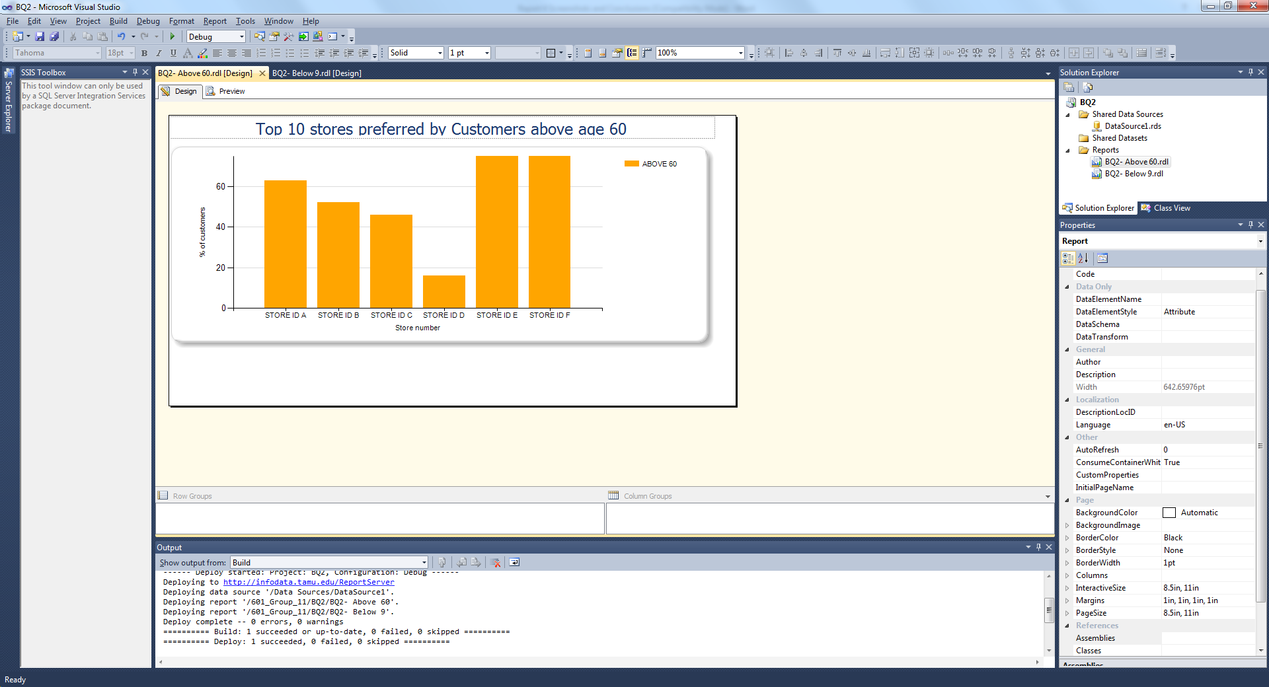

**Browsing Deployed Report**

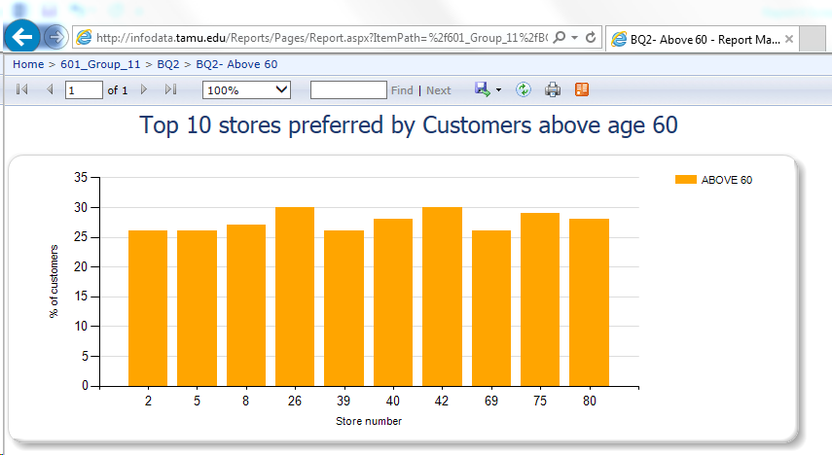

**Conclusion**

We have generated a SSRS report from an independent data mart for answering popularity of different stores in DFF among Kids and elderly groups. For kids and elderly groups, the report plots top 10 popular stores in each case considering percentage of age group visited among the total number of store visits. From this analysis we get the stores popular among the kids and elderly group directly. This is customizable to get top n number of stores among both groups. Report and chart generated with SSRS gives a clear idea of stores popular among kids and elderly group along with margin by which they are popular from the height difference of each plot in the graph.

How the report assists the management:

With popular stores list, now it is up to the upper management to understand what these stores are doing that is attracting these 2 groups and to spread the favorable conditions in this stores to other stores across DFF. Similar demographic analysis can be done by analytics team at DFF and strategies can be built on that for boosting the overall sales of DFF.

## Report generated using Report builder 3.0 for Question 3

As per the reporting plan described in previous parts we are generating a report using Report Builder 3.0 for answering the question number 3.

**Designing Report Using Report Builder**

**Question 3**: Which stores attract people who earn below poverty line?

**Selecting data source**

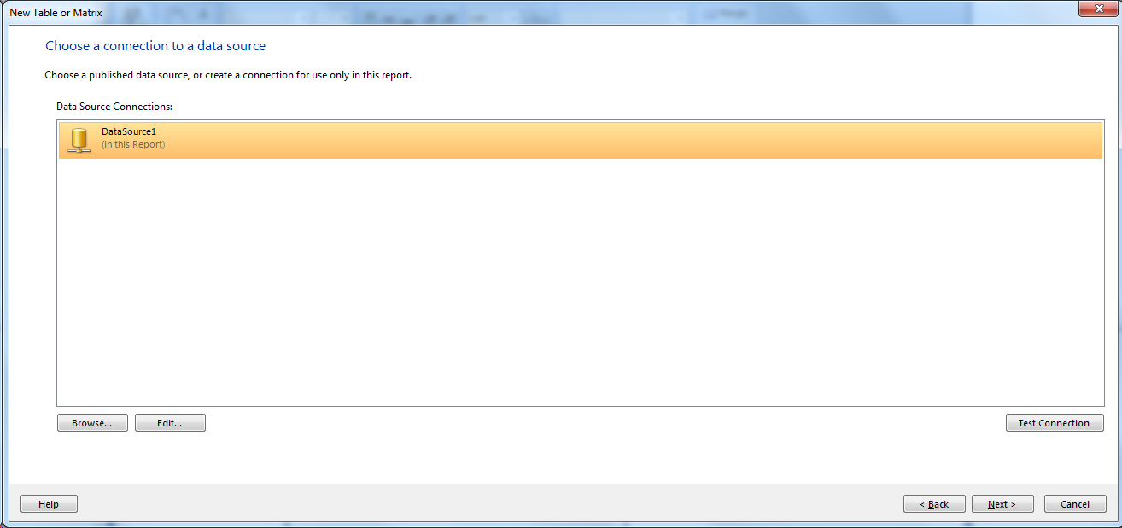

**Designing query for report builder**

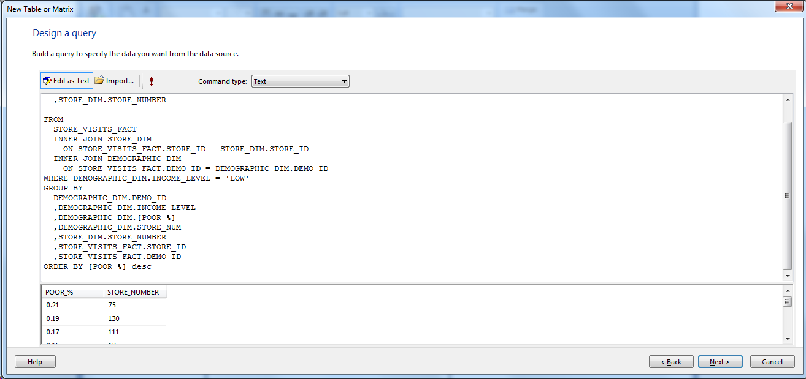

**Creating Table for Report**

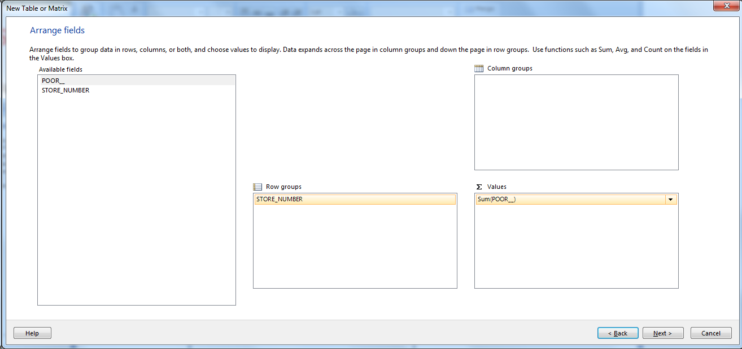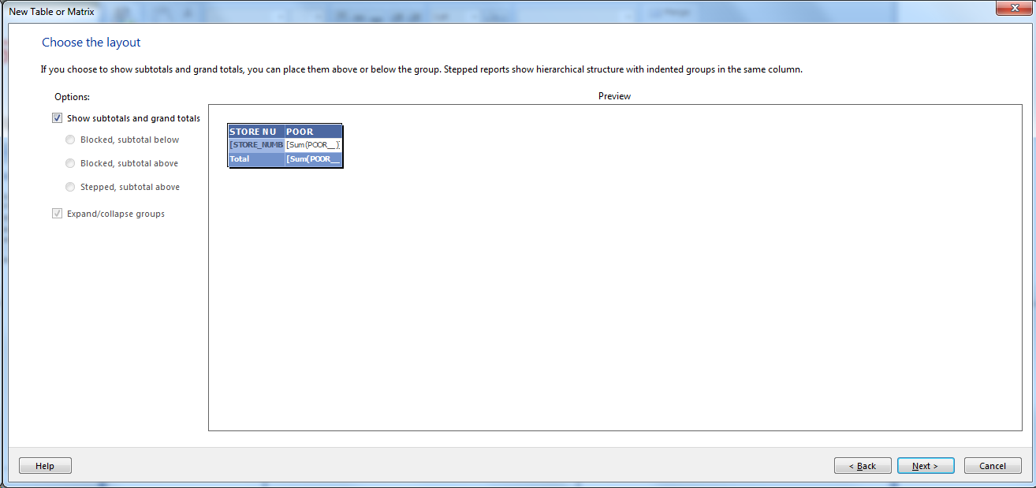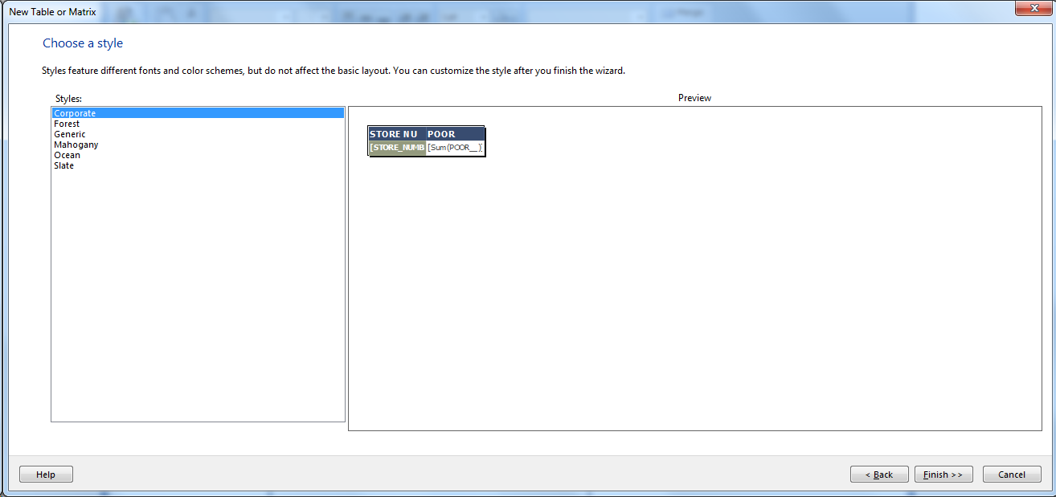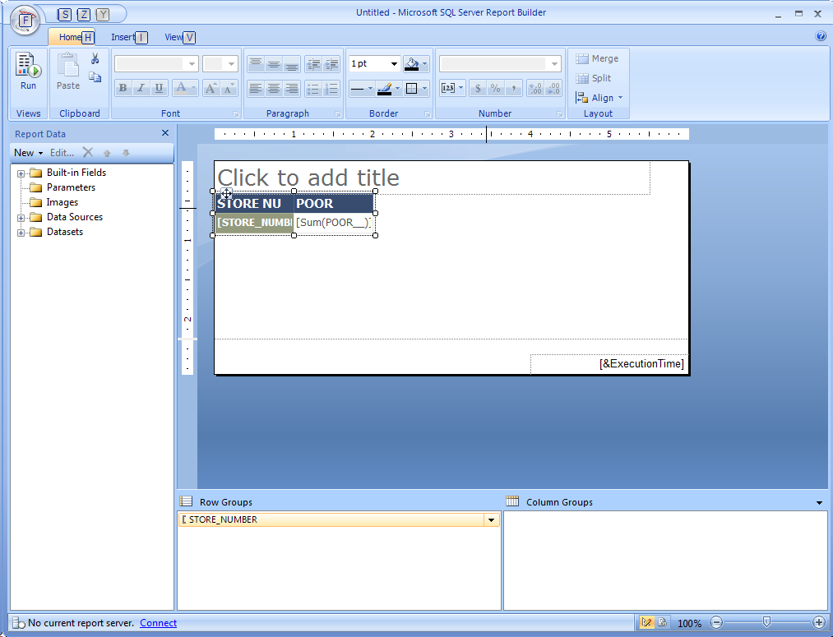

**Browsing Generated Graph**

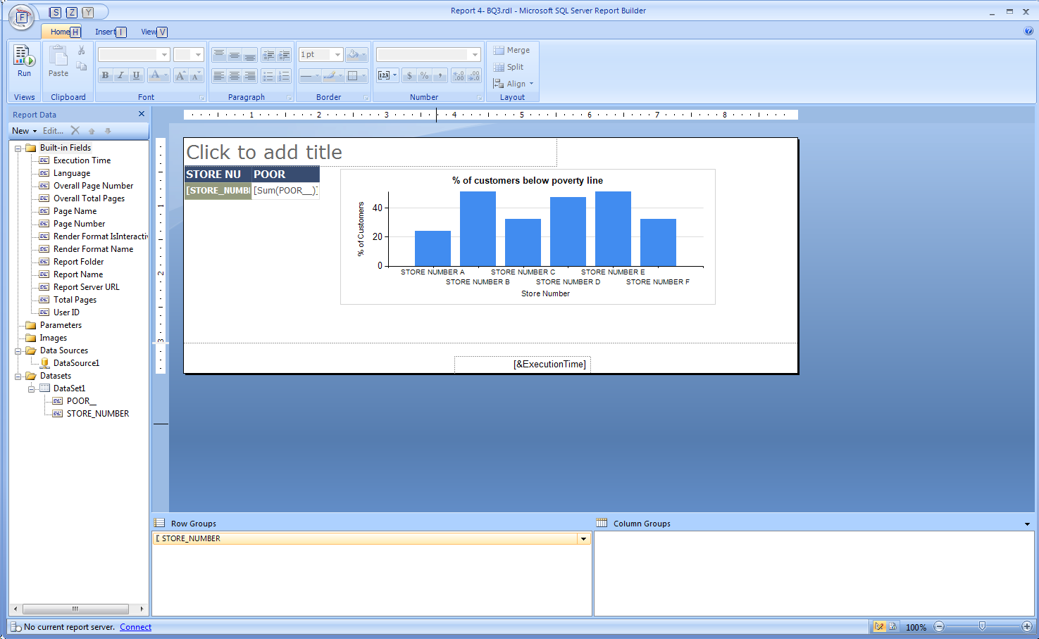

**Snapshot of the report deployed on the server**

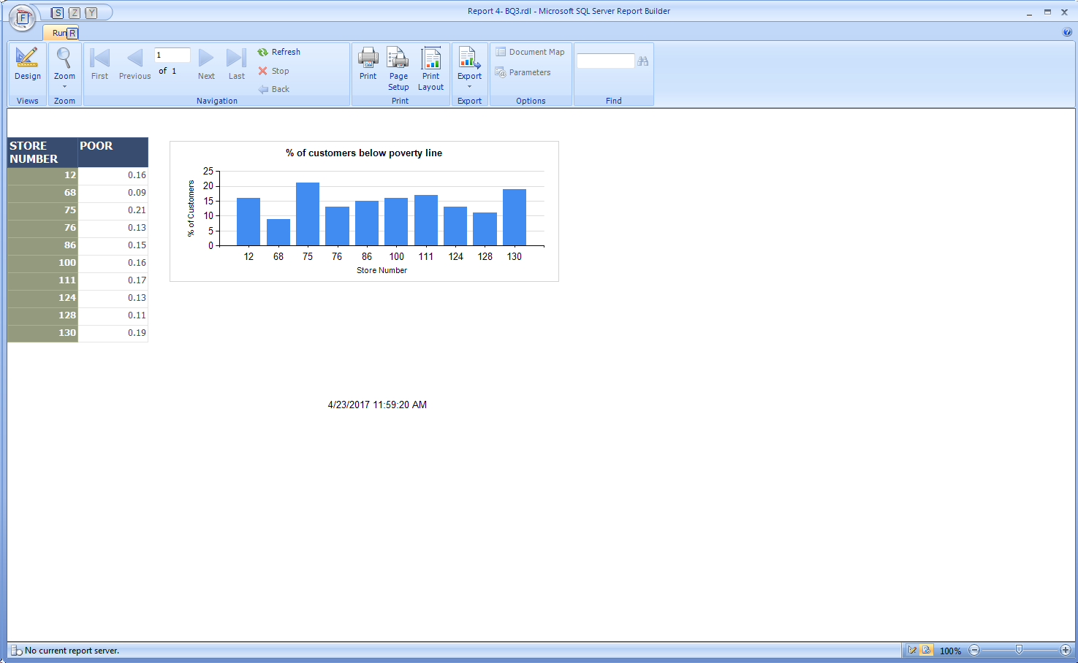

**Conclusion**

We have generated a report using Report Builder 3.0 for answering popularity of different stores in DFF among section of people who earn below poverty line. The report plots Top 10 stores which are popular among people below the poverty line as a percentage of total store visits. From this analysis we got the Store numbers popular among this section of people. This we can customize to get top n number of stores among people below poverty line. Report and chart generated with Report Builder 3.0 gave a clear idea of stores popular among people who earn below poverty line along with margin by which they are popular from the height difference of each plot in the graph.

How the report assists the management:

As we got the popular stores list, now it is up to the management to prepare the store increase the popularity among people below poverty line after analyzing the factors associated with this. This question is similar to the question number we answered previously and more such demography analysis can be done in similar way.

## Report generated using Report builder 3.0 for Question 4

As per the reporting plan described in previous parts we are generating a report using Report Builder 3.0 for answering the question number 4.

**Question 4**: What is the effect of introducing coupons on total number of customer visits?

**Selecting data source for Report Builder 3.0**

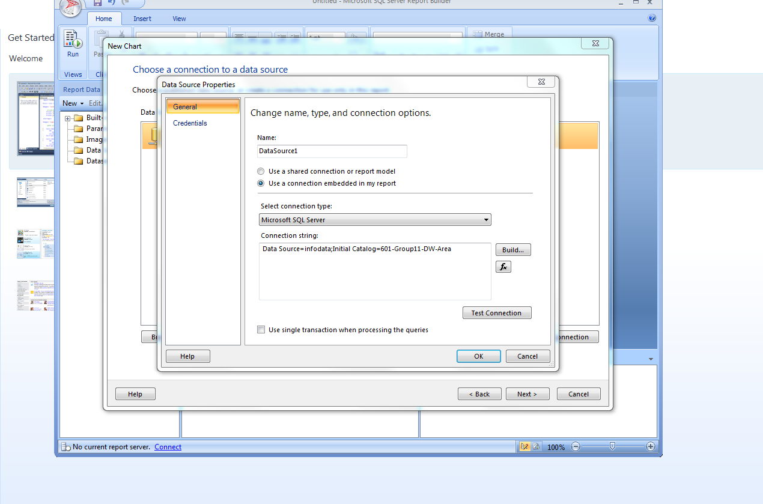

**Designing query to pull the data required for report**

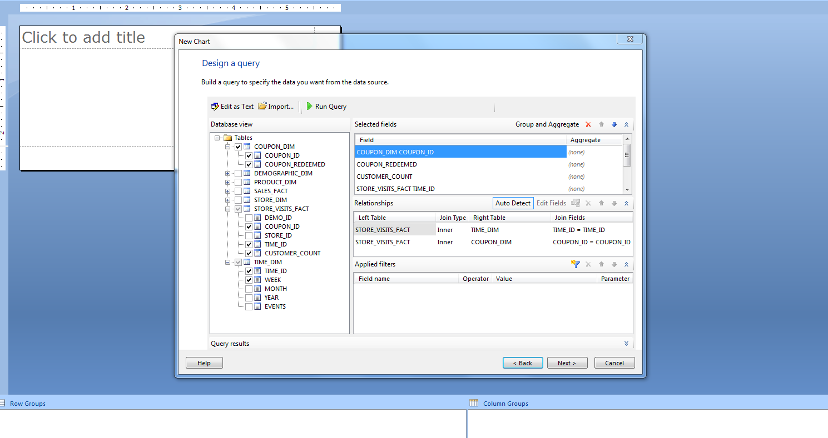

**Assigning fields for the report table**

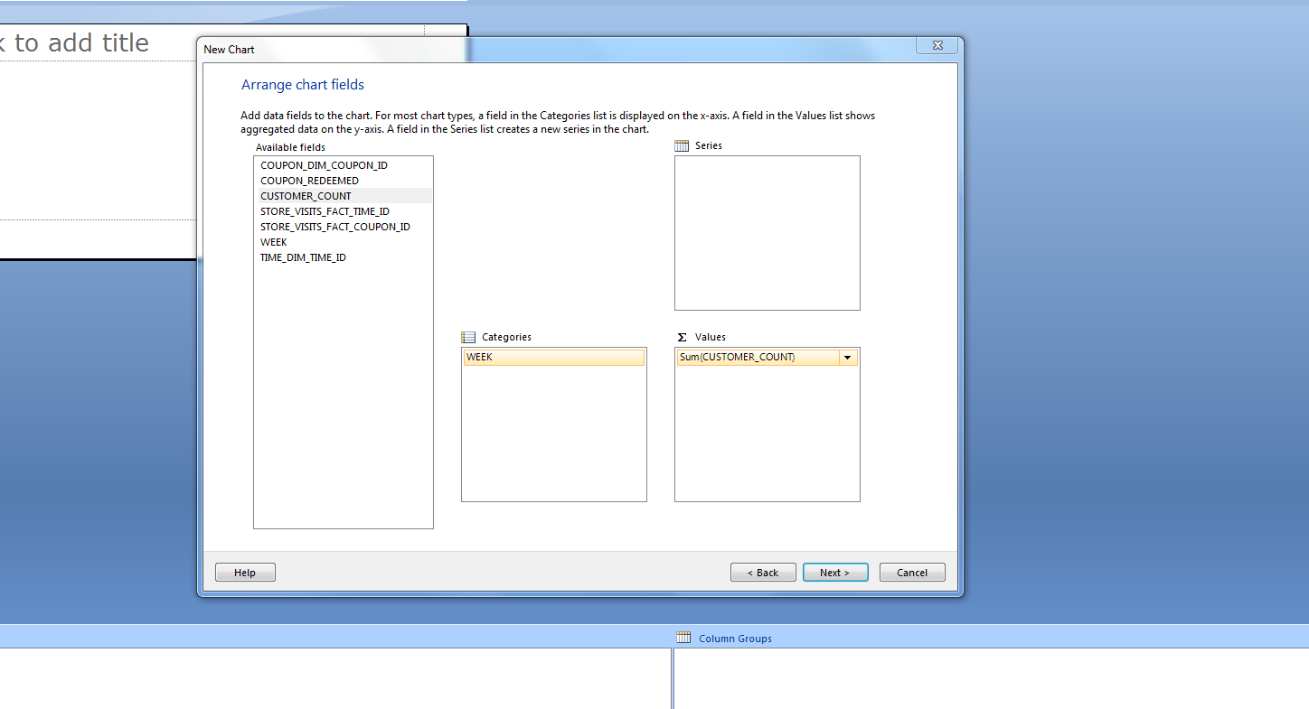

**Configuring the horizontal axis interval in the report**

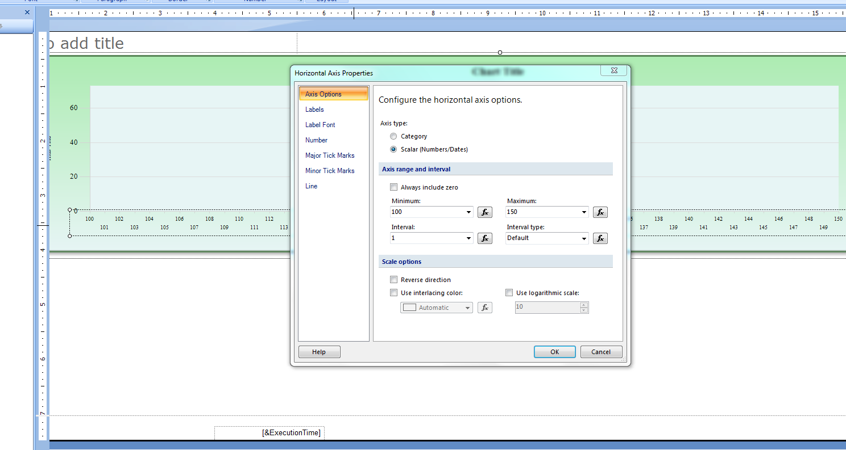

**Coupon redeemed values plotted on weekly basis**

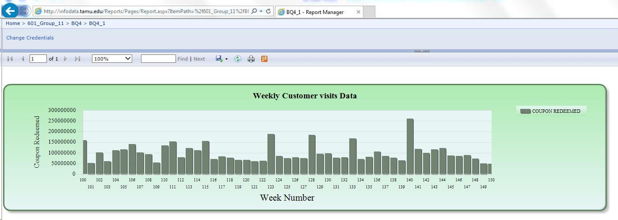

**Customer Visits data plotted for the same weeks for which Coupon redeemed is plotted**

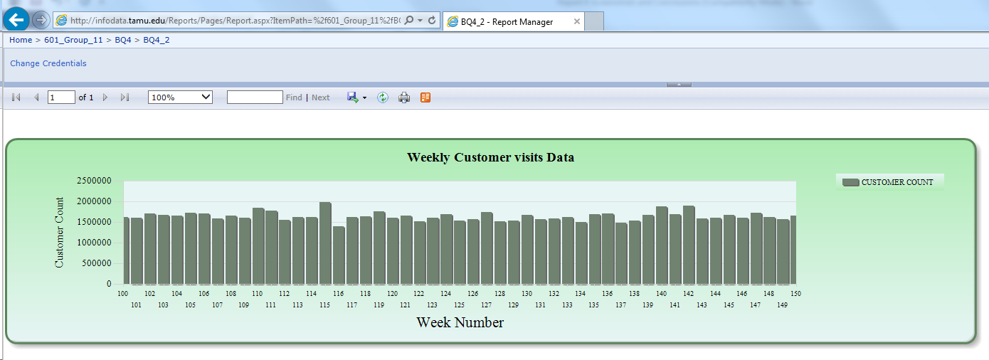

**Conclusion**

There is a general opinion that introducing coupons increases the customer flow. Hence in this question we expected a correlation between the Coupons redeemed and number of customer visits as Coupon issued is considered as kind of freebie to the customers. From the graph we could conclude that number of customer visits is almost constant among the weeks under consideration here, whereas the coupon redeemed have its own peaks and lows for the weeks under consideration. From this it is evident that Coupon redeemed have no relation with the number of customer visits.

How the report assists the management:

As per the result Coupon redeemed might have only decreased the total sales due to discounts and has no direct effect in increase in Customer counts. So the management can look into decreasing the coupons disbursed as the number of customer visits remains unaffected.

## Cubes using SSAS from an independent data mart for Question 5

As per the reporting plan described in previous parts we are generating a report SSAS using an independent data mart for answering the question number 5.

**Question 5:** What is the trend of a product demand in different price-tiers?

**Selecting data source for SSAS**

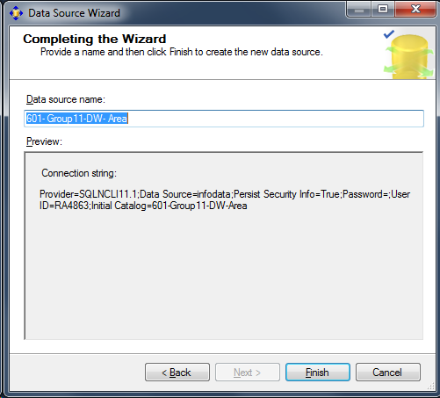

**Designing data source view**

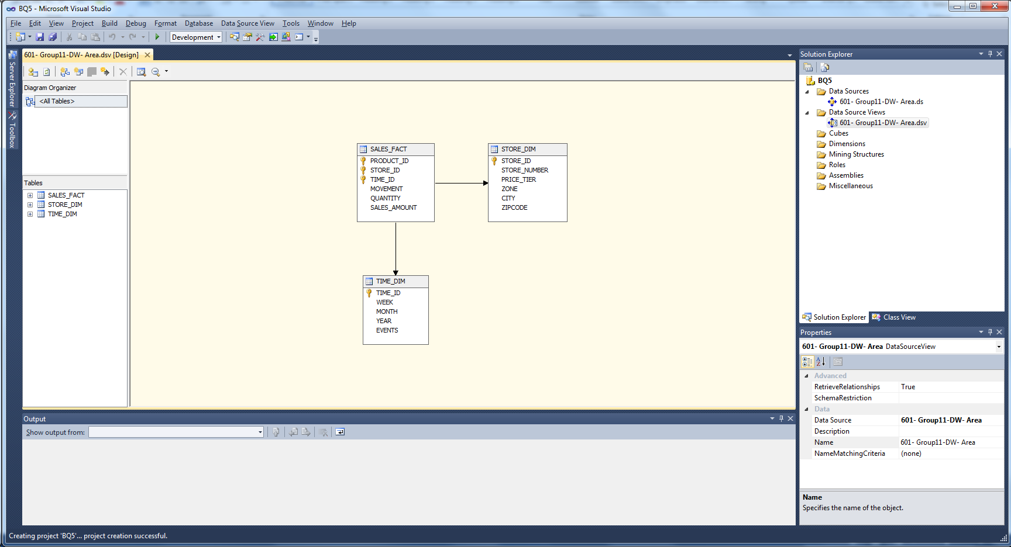

**Fact table set as the measures Group table**

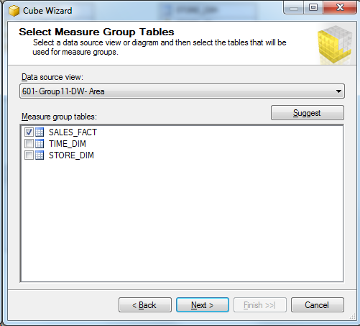

**Completing the wizard after defining dimensions**

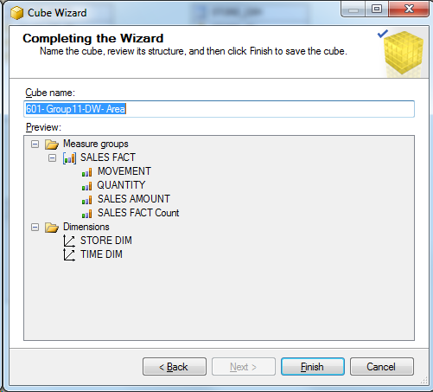

**Created Cube**

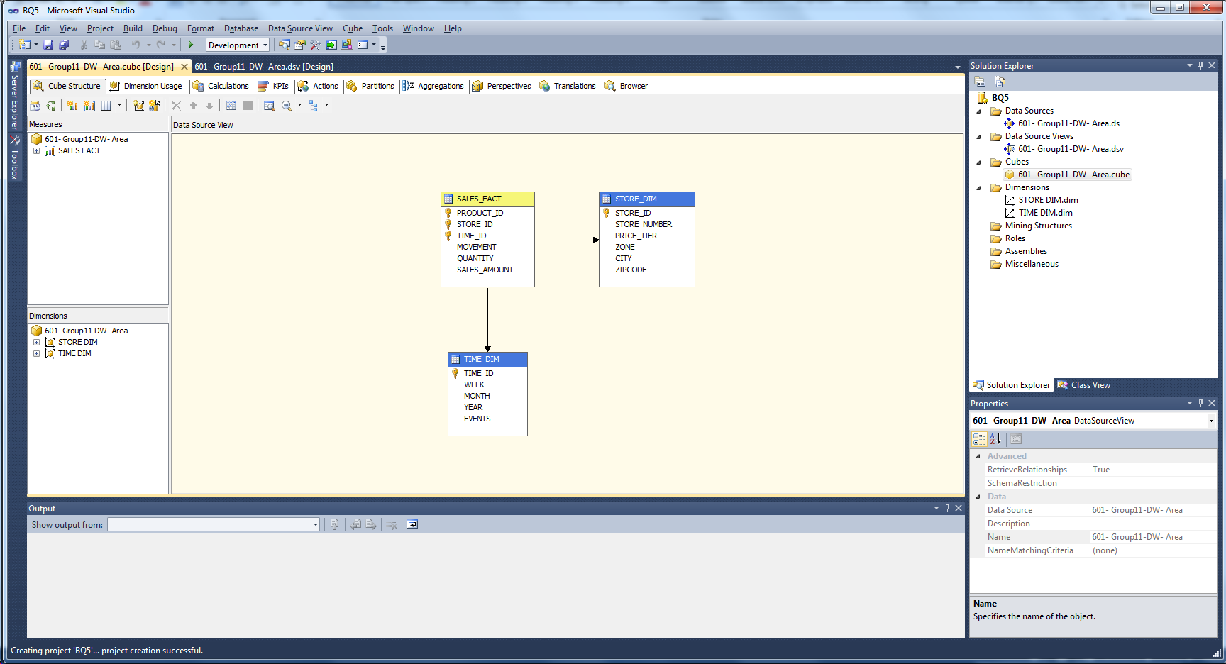

**Defining hierarchies for drill down and roll up**

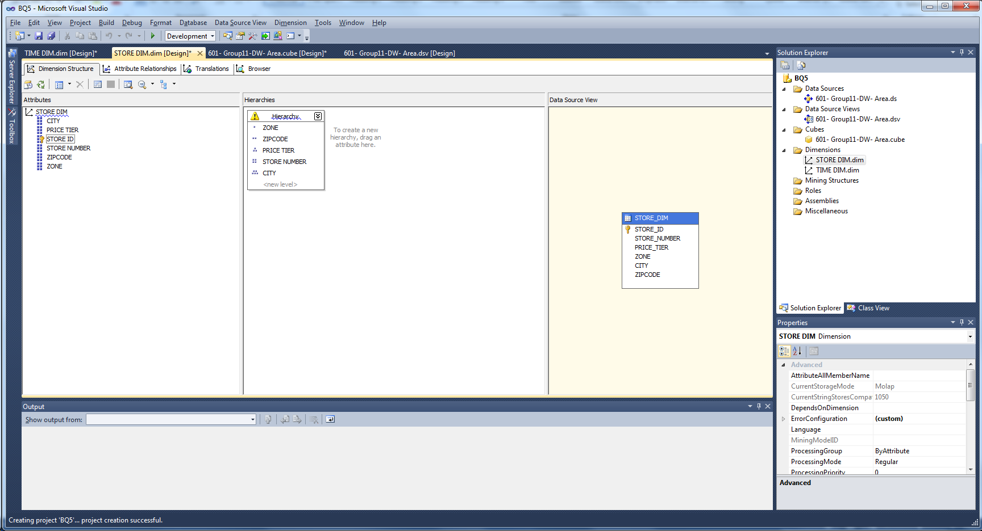

**Deploying Cube for analysis**

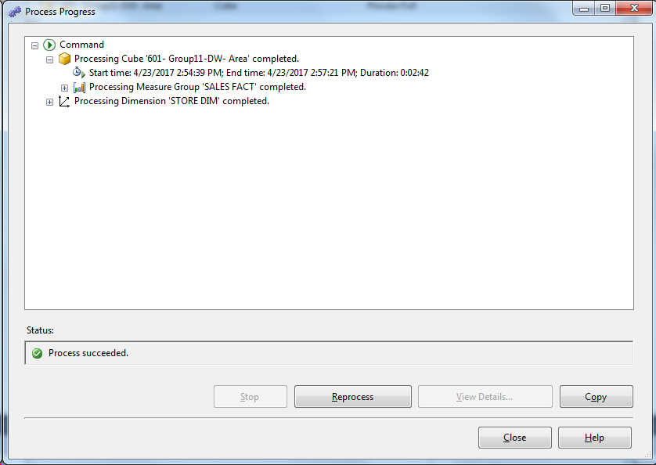

**Report generated using Pivot table**

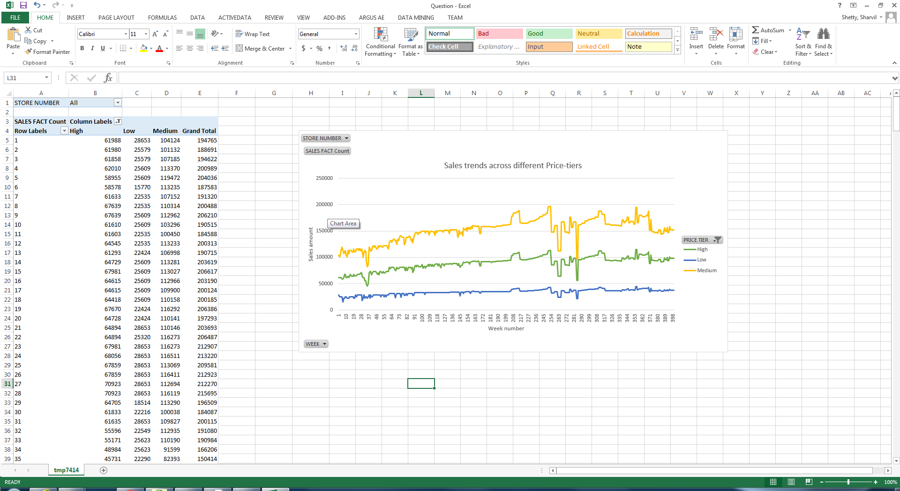

**Sales chart for different Price Tiers**

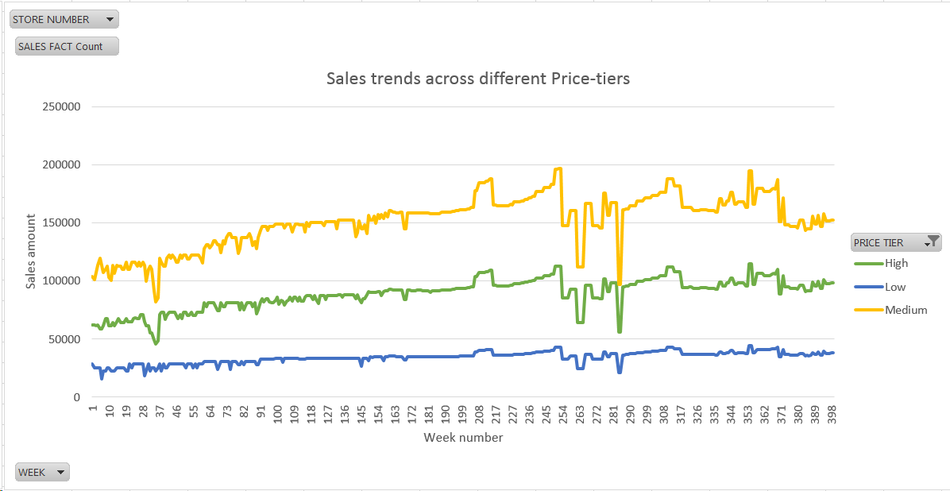

**Conclusion**

Sales amount in each price tier is calculated by adding individual store sales amount in each price tier on weekly basis. So the graph was plotted against Sales amount and Week. Surprisingly we got result from analysis had strikingly similar correlation between the different Price tiers High, Low and Medium. Whenever there is a dip or peak in sales amount for a particular week for any price tier the same trend was followed by other price tiers. This was important finding after doing analysis for question 5.

How the report assists the management:

The difference in Sales amount across different price tiers remain constant throughout the analysis duration. Management can dig up further for knowing the reasons for constant difference across varying price tiers.

# **References**

1. Nevo, Aviv and Catherine Wolfram, “Why do Manufacturers Issue Coupons? An Empirical Analysis of Breakfast Cereals," The RAND Journal of Economics, 33 (Summer 2002): 319-339.
2. Sivakumar, K., "Quality-Tier Competition and Optimal Pricing," Journal of Business Research 33 (1995): 251-260.
3. Lira, Loreto, "Why Do Some Prices in the Retail Sector Drop When Demand Rises? Evidence from the Chilean Case," Revista ABANTE 10 (Octubre 2007): 151-168
4. <https://en.wikipedia.org/wiki/Dominick's>
5. <https://research.chicagobooth.edu/marketing/databases/dominicks/docs/1994-shelfmanagement.pdf>
6. Drèze, Xavier; Hoch, Stephen J.; Purk, Mary E. (1994): *Shelf Management and Space Elasticity*
7. <http://research.chicagobooth.edu/marketing/databases/dominicks/papers.aspx>
8. [www.chicagobooth.edu/research/kilts/marketing-databases/dominicks/demo](http://www.chicagobooth.edu/research/kilts/marketing-databases/dominicks/demo)
9. <https://research.chicagobooth.edu/marketing/databases/dominicks/docs/2002_Why_Do_Manufacturers.pdf>
10. <https://research.chicagobooth.edu/marketing/databases/dominicks/docs/1995-Quality-TierCompetition.pdf>
11. <https://research.chicagobooth.edu/marketing/databases/dominicks/docs/2007-WhyDoSomePricesDrops.pdf>